Microsoft (70-533): Implementing Microsoft Azure Infrastructure Solutions | MeasureUp | Practice Test | Q/A 1-167 | Microsoft Official

[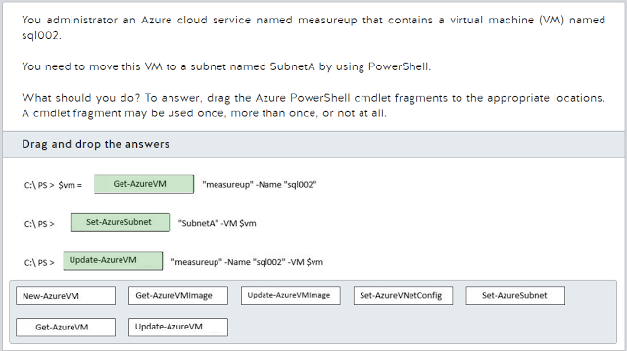](https://3.bp.blogspot.com/-sF3Owlq1bfk/WSCIqZIJpiI/AAAAAAAACaQ/xGupZYunetgKjavxP2I8OVUJEH6h193WwCLcB/s1600/2017-05-20%2Bat%2B22-12-33.png)

[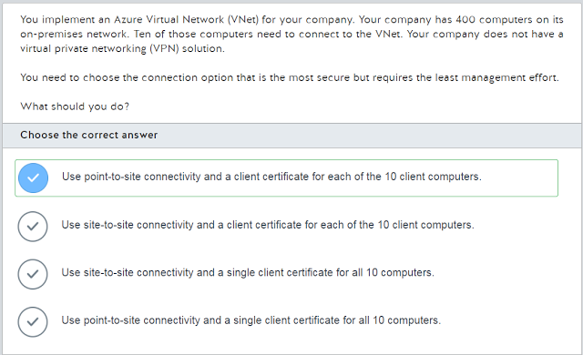](https://3.bp.blogspot.com/-BL-Jq_r4V1A/WSCIqJFE6iI/AAAAAAAACaM/HaYCL01AfuIlOqsySYbqZIXLHbwpPwnRACLcB/s1600/2017-05-20%2Bat%2B22-12-54.png)

[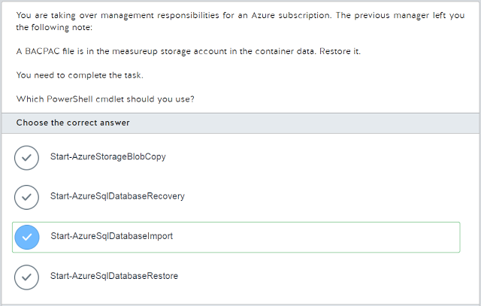](https://3.bp.blogspot.com/-4B9koPSL4t0/WSCIp0ZT0XI/AAAAAAAACaI/1EKFdToRVi80oGRKrSdJFn2vT65bg0IggCLcB/s1600/2017-05-20%2Bat%2B22-13-13.png)

[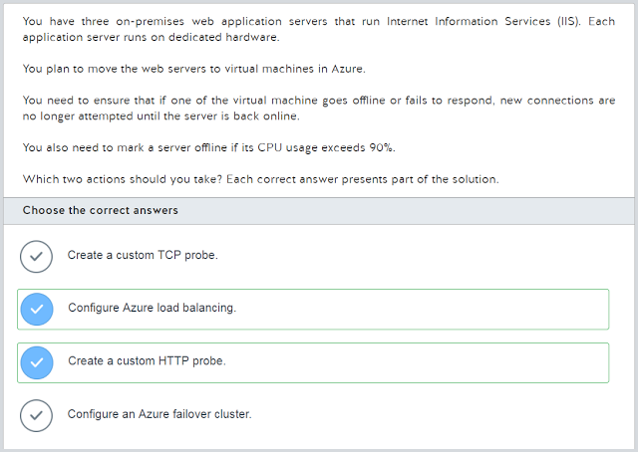](https://3.bp.blogspot.com/-bFLzQOSQwQM/WSCIrVt_-pI/AAAAAAAACaY/4zEyMITghR4E6b551xNCw4eNRAedV5lqgCLcB/s1600/2017-05-20%2Bat%2B22-13-33.png)

[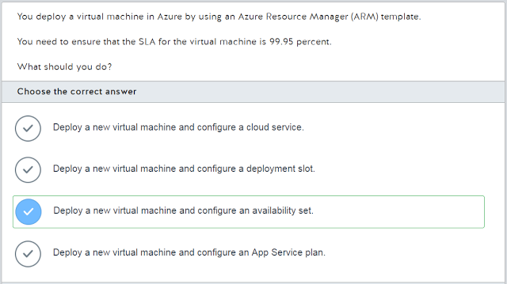](https://3.bp.blogspot.com/-6IoF1RtqOmI/WSCIrZ0C-KI/AAAAAAAACaU/299TMbLqksE43Yo7oFQ-UPkbGsfSZlUJQCLcB/s1600/2017-05-20%2Bat%2B22-13-58.png)

[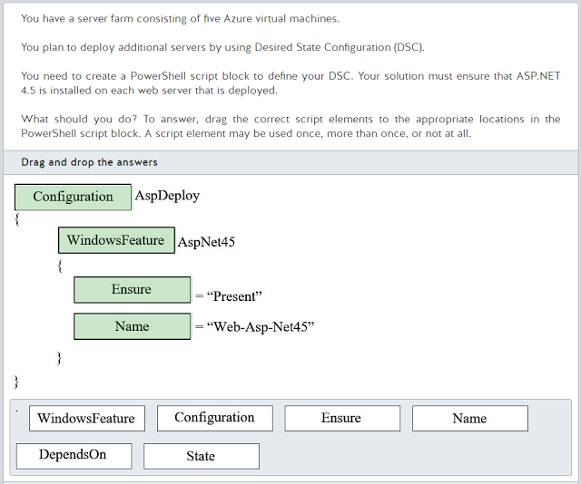](https://2.bp.blogspot.com/-6Gn-8ulsKKE/WSCIsNFHyDI/AAAAAAAACac/miPYuZushRUaKOyevLzXQ8GucxHCEVEHACLcB/s1600/2017-05-20%2Bat%2B22-14-36.png)

[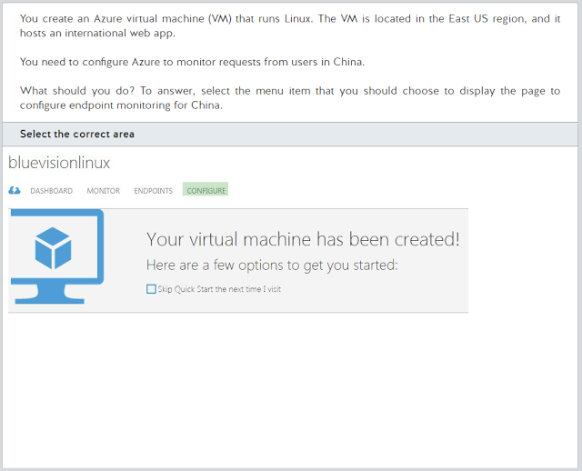](https://4.bp.blogspot.com/-m_VQv37nanY/WSCItA906ZI/AAAAAAAACak/0h_7L2bxVYARTYj4NtTmTue2068q1bIeQCLcB/s1600/2017-05-20%2Bat%2B22-15-07.png)

[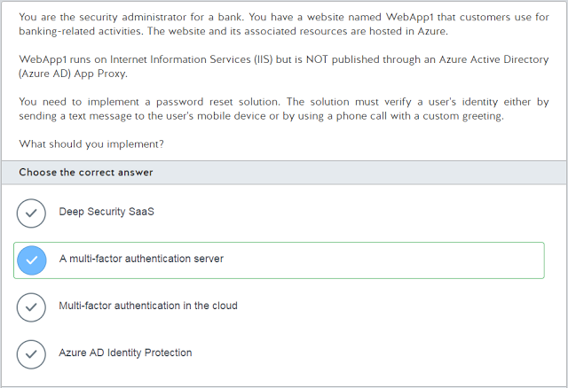](https://2.bp.blogspot.com/-pJQvSqm8WlU/WSCIshv4nPI/AAAAAAAACag/na-eOTjFjioUZY9DD7bQHlItFUvEKGnEACLcB/s1600/2017-05-20%2Bat%2B22-15-26.png)

[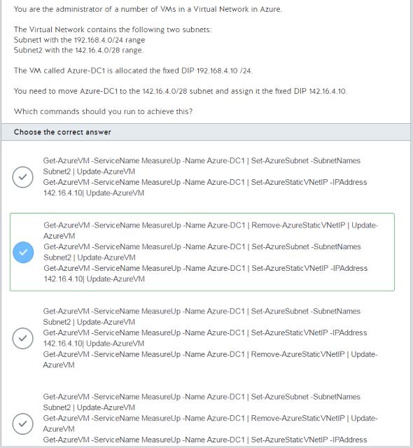](https://4.bp.blogspot.com/-Sg-yil9y9Rw/WSCItjUiCxI/AAAAAAAACao/8VwjYNTIZ4YyF24IIDTvvEDM8iyfQLcFACLcB/s1600/2017-05-20%2Bat%2B22-16-02.png)

[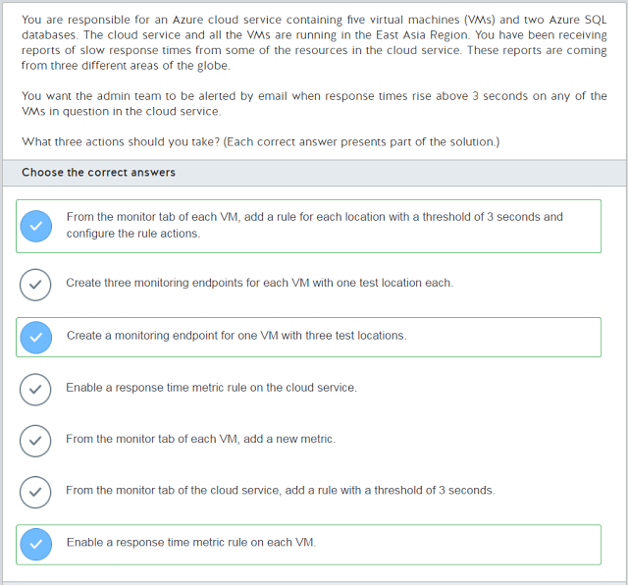](https://1.bp.blogspot.com/-nnuXBODODs4/WSCItyb9uvI/AAAAAAAACas/-bC7JK_K2b0R15UjlJOntsptiZvKd-bHwCLcB/s1600/2017-05-20%2Bat%2B22-16-29.png)

[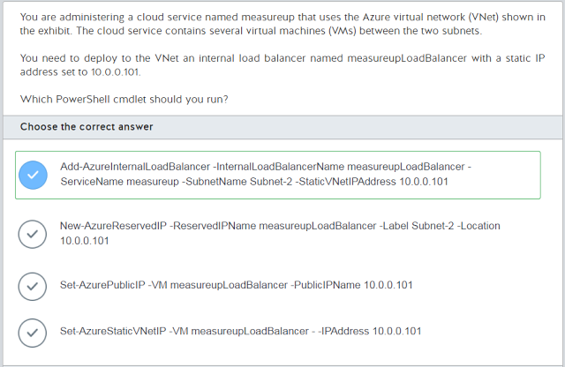](https://2.bp.blogspot.com/-MjRuCdDAdKk/WSCIuMMam4I/AAAAAAAACaw/btjApm1OHLoQnNfoRgsK7oA6nKXz4w0gACLcB/s1600/2017-05-20%2Bat%2B22-16-55.png)

[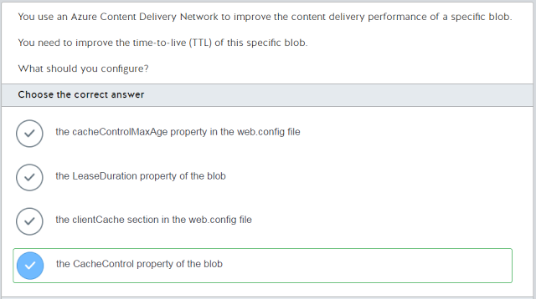](https://3.bp.blogspot.com/-dPui25qdMF0/WSCIuuR3G7I/AAAAAAAACa0/wOiq3AexUJY5veNfjjHbftTQzDsNi1tcwCLcB/s1600/2017-05-20%2Bat%2B22-17-17.png)

[](https://1.bp.blogspot.com/-XaTHsmSvCw4/WSCIvIIeCwI/AAAAAAAACa4/4eD5hNMFTFolSWNfKXZ7zGuJafOXtLRjgCLcB/s1600/2017-05-20%2Bat%2B22-17-43.png)

[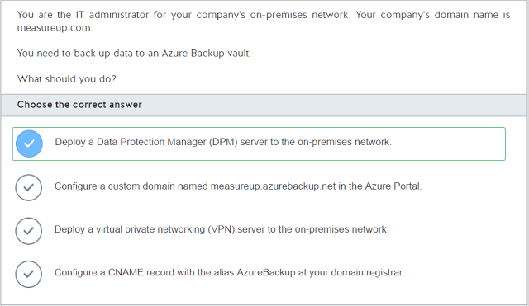](https://4.bp.blogspot.com/-ahGu3Cyl0IE/WSCIvJ6g9MI/AAAAAAAACa8/0HUe6mo9aCcN8W6VNJa-0jX0j-LHsXfFACLcB/s1600/2017-05-20%2Bat%2B22-18-11.png)

[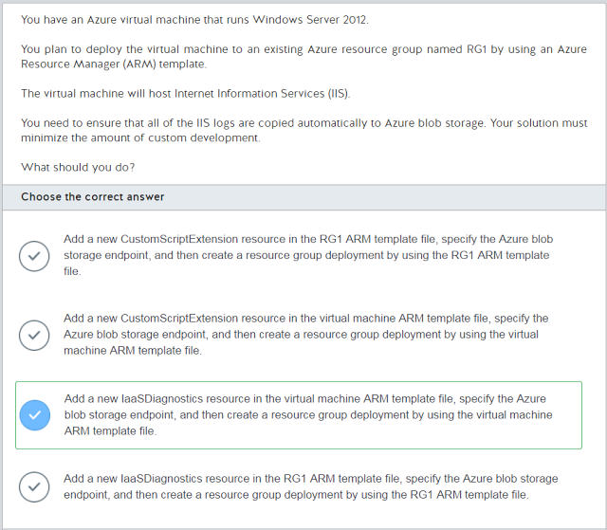](https://3.bp.blogspot.com/-3OlzJcOWjlQ/WSCIvwqFG2I/AAAAAAAACbA/i4NZZU24E7YuKEfTSoWDTe2W12dvBnsCgCLcB/s1600/2017-05-20%2Bat%2B22-18-33.png)

[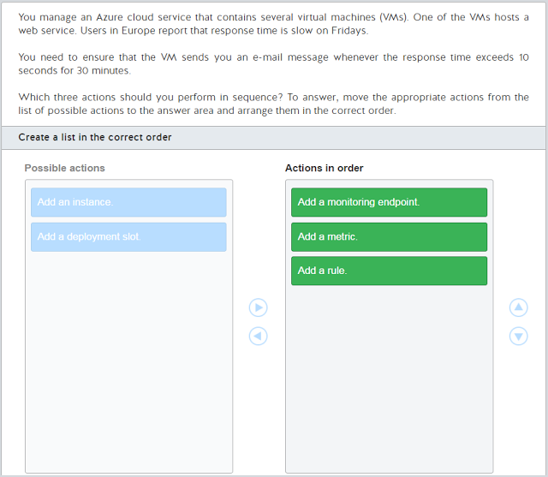](https://4.bp.blogspot.com/-ch-U-jsCRoE/WSCIwj0nQTI/AAAAAAAACbI/nYefeuuD56otf1q0c5fKv_LLfcPxDIAmACLcB/s1600/2017-05-20%2Bat%2B22-27-50.png)

[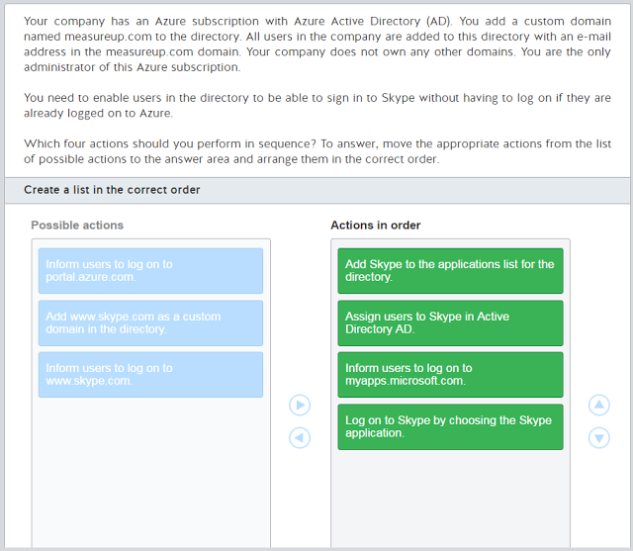](https://1.bp.blogspot.com/-nAChDNkT0h0/WSCIwXMfoYI/AAAAAAAACbE/5MRVIZnt9nwHX1ULwWgq5oVHPS_U4Gn3gCLcB/s1600/2017-05-20%2Bat%2B22-28-03.png)

[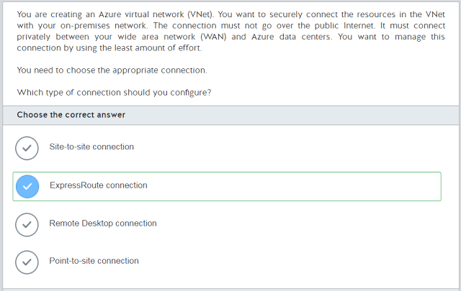](https://4.bp.blogspot.com/-3Bye9dYzijM/WSCIxZ1mSII/AAAAAAAACbM/LZbxBwQbKr8zfWFrKpFgTkVDX3FGmMlDwCLcB/s1600/2017-05-20%2Bat%2B22-28-25.png)

[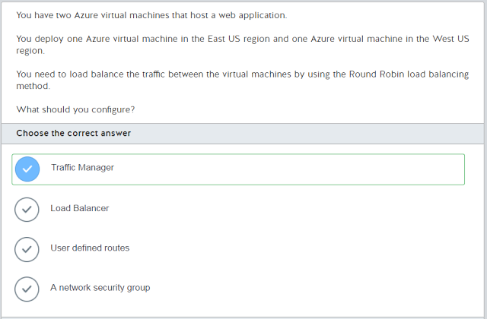](https://2.bp.blogspot.com/-OtVIcIxi4-E/WSCIyC54lHI/AAAAAAAACbU/h3SLNq3diDEpOW4Q4TLetqKIZ-vkPs6TgCLcB/s1600/2017-05-20%2Bat%2B22-28-50.png)

[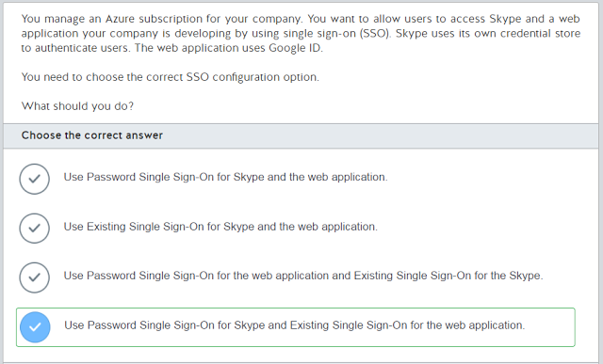](https://1.bp.blogspot.com/-yEqwkTDUIXQ/WSCIyMl3aQI/AAAAAAAACbQ/IxCoXwLF9i4X5NvbXxhcmaTHGJOCFaHPgCLcB/s1600/2017-05-20%2Bat%2B22-29-11.png)

[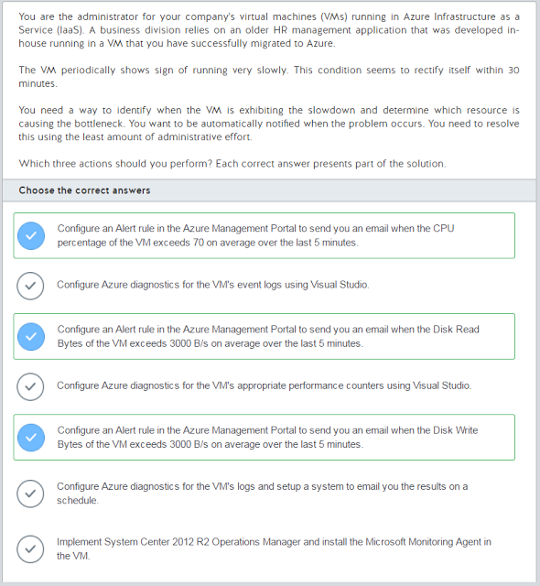](https://4.bp.blogspot.com/-4y4bQmo-Cac/WSCIy-Y6u8I/AAAAAAAACbY/vleMrYD_obMSqiEK0m5lMLayVGrziUvjQCLcB/s1600/2017-05-20%2Bat%2B22-29-49.png)

[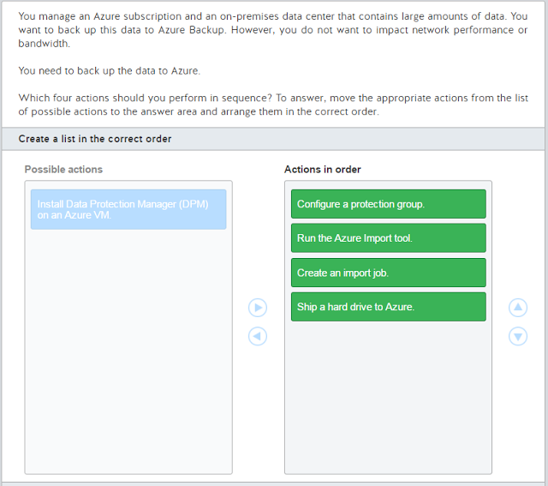](https://2.bp.blogspot.com/-4UtQ9cQzcCM/WSCIzFwjaYI/AAAAAAAACbc/Go42yNM2o_spXVMKfXT9g_MiGmZizBC4gCLcB/s1600/2017-05-20%2Bat%2B22-30-07.png)

[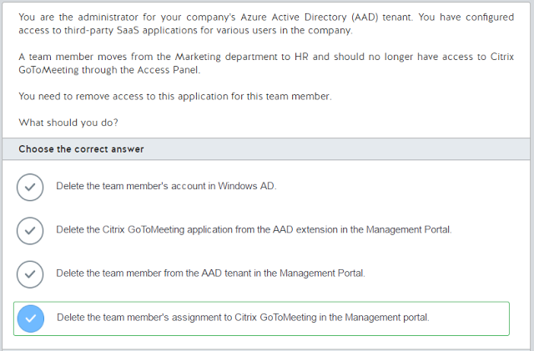](https://3.bp.blogspot.com/-OXl2QYIkCPM/WSCIzoQ179I/AAAAAAAACbg/ZmzZ7NBFOisydAlOJW1Idqtxq0t7R6EPwCLcB/s1600/2017-05-20%2Bat%2B22-30-22.png)

[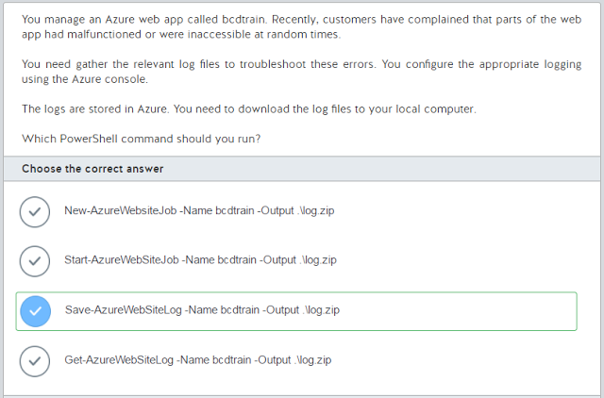](https://3.bp.blogspot.com/--3iUwck8BjU/WSCIz9rj9sI/AAAAAAAACbk/WN4FQyzmvwE1SbVBPdsUq6G49It1uCGGACLcB/s1600/2017-05-20%2Bat%2B22-30-41.png)

[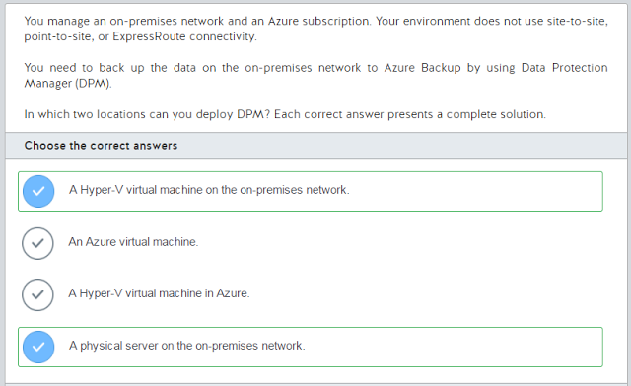](https://4.bp.blogspot.com/-s-xgX3WLNI0/WSCI0XexbmI/AAAAAAAACbo/mRpQvlpt_2sD6jAmMGEqD-zL6xTqBexwgCLcB/s1600/2017-05-20%2Bat%2B22-30-57.png)

[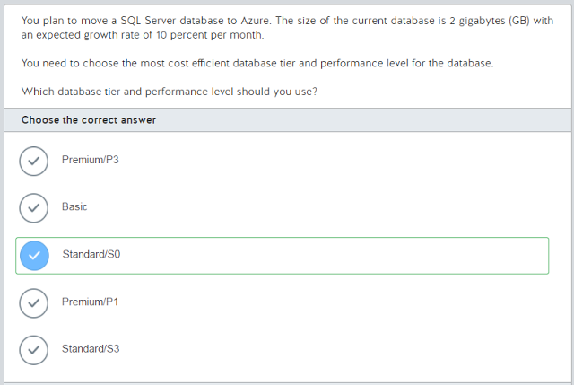](https://2.bp.blogspot.com/-IGVERozfKgs/WSCI0asyRTI/AAAAAAAACbs/LoN-L2ZbWDcj0qRXABjvWfxYXPfAhIHqQCLcB/s1600/2017-05-20%2Bat%2B22-31-13.png)

[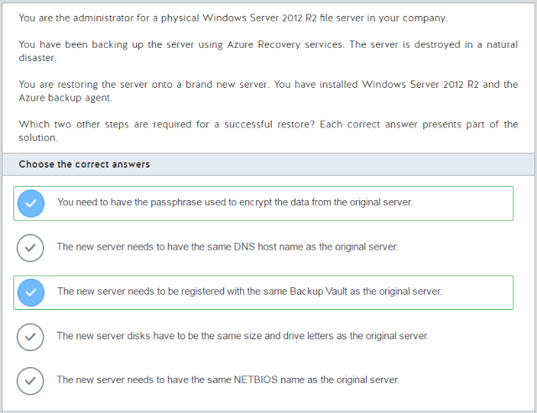](https://1.bp.blogspot.com/-mXh14UtW_AE/WSCI1Enzi6I/AAAAAAAACbw/JFH2u6ZXkZ0dwR0zuFCjRQTS1xPNafB5wCLcB/s1600/2017-05-20%2Bat%2B22-31-28.png)

[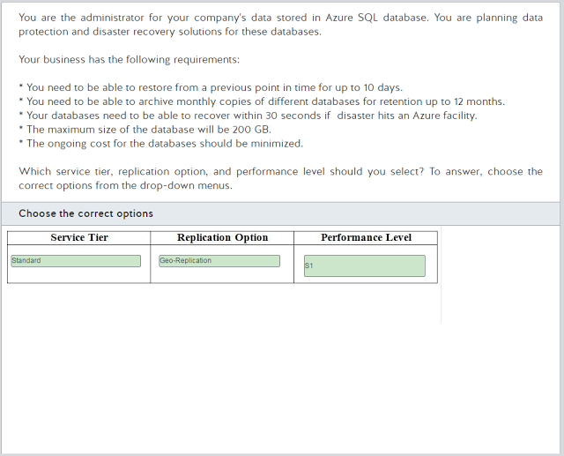](https://1.bp.blogspot.com/--L23IOpCU4A/WSCI1a3YE-I/AAAAAAAACb0/NxTmAi_sh64I-5O2h27ECaJuLeE1vPjiwCLcB/s1600/2017-05-20%2Bat%2B22-31-51.png)

[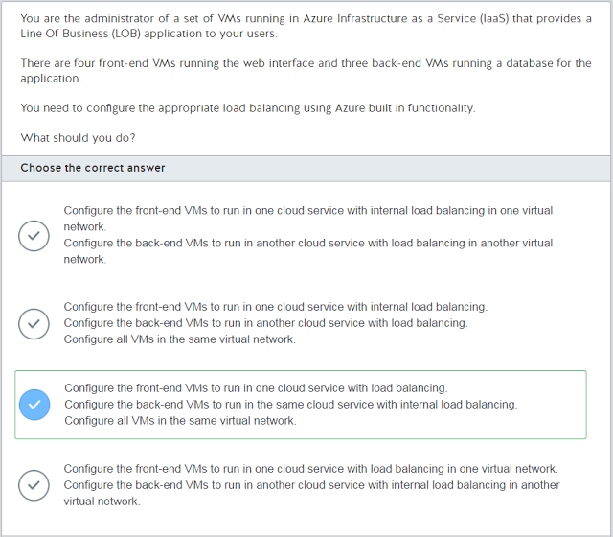](https://3.bp.blogspot.com/-6XGPQaJ9zpo/WSCI1jgNvCI/AAAAAAAACb4/huRWuDkCTAAdIpYKOtceAtzUFtpfKMemgCLcB/s1600/2017-05-20%2Bat%2B22-32-16.png)

[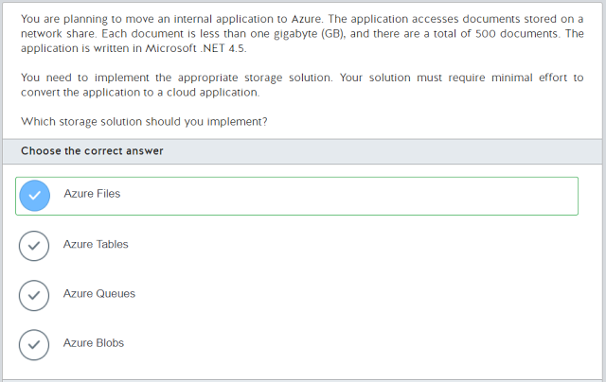](https://1.bp.blogspot.com/-TvLAGJWwt4o/WSCI1lYvb7I/AAAAAAAACb8/O8GoDbyeLNUTXC6IY3QHq3Xk3fGKPZ9WwCLcB/s1600/2017-05-20%2Bat%2B22-32-36.png)

[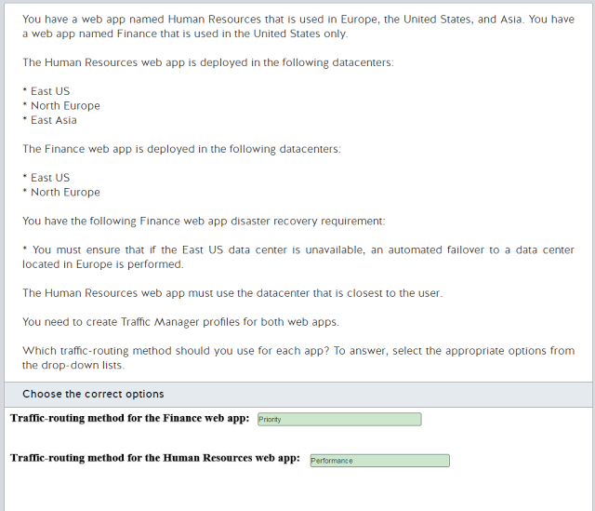](https://4.bp.blogspot.com/-7ysMbdL47Xc/WSCI15fm6cI/AAAAAAAACcA/TjdSQFeAUYUXUVoSnz32JX_poS7x70j_wCLcB/s1600/2017-05-20%2Bat%2B22-32-53.png)

[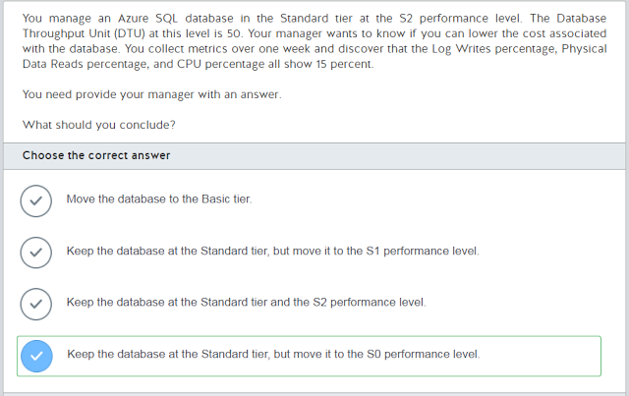](https://4.bp.blogspot.com/-x8zKM074I1g/WSCI2RI1VXI/AAAAAAAACcE/Bts5t7IQSeg_HOSYdmyaa2zkqUTTpSTrgCLcB/s1600/2017-05-20%2Bat%2B22-33-15.png)

[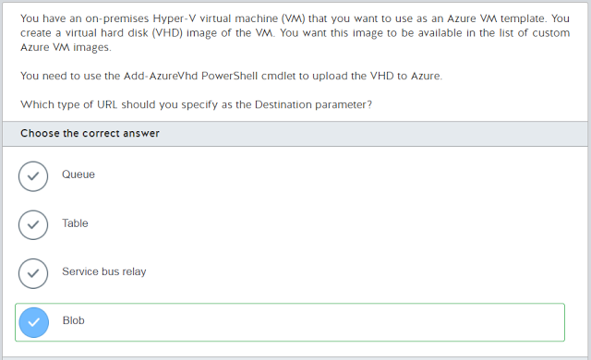](https://2.bp.blogspot.com/-lKs_qgAneek/WSCI2cYThpI/AAAAAAAACcI/A76iFLumpH8phCzpRKv_X4alb3qkm6GgwCLcB/s1600/2017-05-20%2Bat%2B22-33-33.png)

[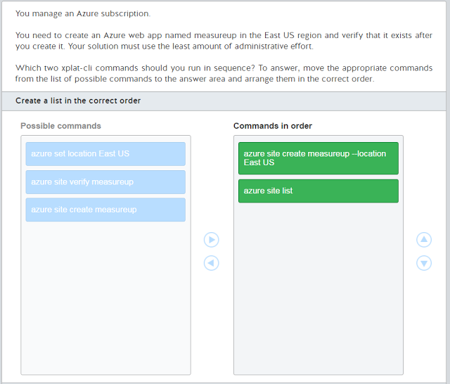](https://4.bp.blogspot.com/-7Xk7dzdpd4U/WSCI2yQsSCI/AAAAAAAACcM/eIa7Sjjf3pUZyrxOqluu-WhC8GhCZAXIgCLcB/s1600/2017-05-20%2Bat%2B22-33-46.png)

[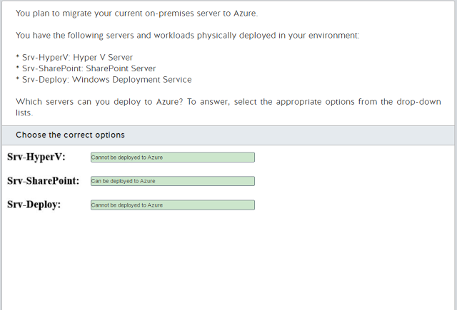](https://3.bp.blogspot.com/-fW9AVZWq2Tc/WSCI3L4o5-I/AAAAAAAACcQ/qCFfFJewtignGBvUQkz9m_riJ-ndHs-gACLcB/s1600/2017-05-20%2Bat%2B22-33-58.png)

[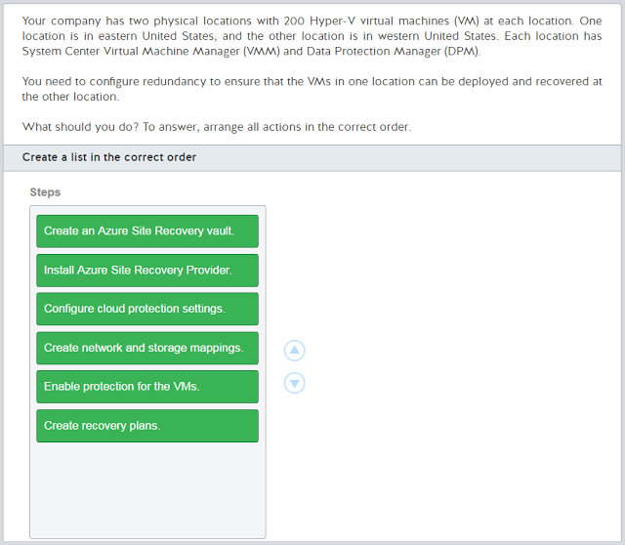](https://4.bp.blogspot.com/-SNm8AHXoaXM/WSCI3W1D3YI/AAAAAAAACcU/ZK8WfZpgKIklyPnsnFYUaiAXuogrppTkACLcB/s1600/2017-05-20%2Bat%2B22-34-23.png)

[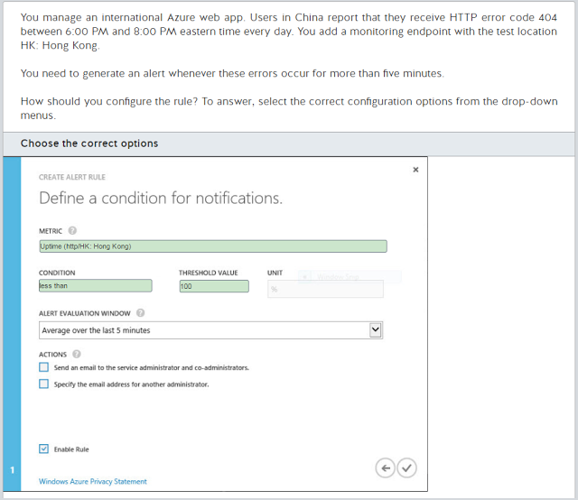](https://4.bp.blogspot.com/-_BB9lFAEOF4/WSCI3cEc_9I/AAAAAAAACcY/N8WCxCa_-qAxxgBt_z2vXO86zXn59menQCLcB/s1600/2017-05-20%2Bat%2B22-34-41.png)

[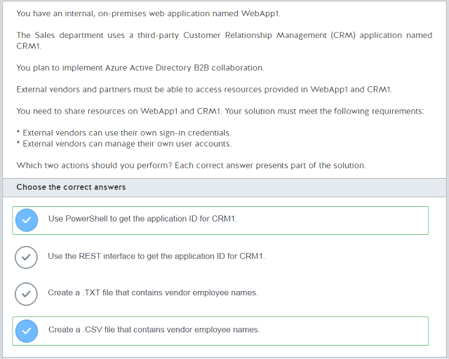](https://3.bp.blogspot.com/-YlvXuFMOStE/WSCI3xUY5SI/AAAAAAAACcc/Wbhjd4pVCfYL7UCgr01kpO6KufNx41XGgCLcB/s1600/2017-05-20%2Bat%2B22-35-00.png)

[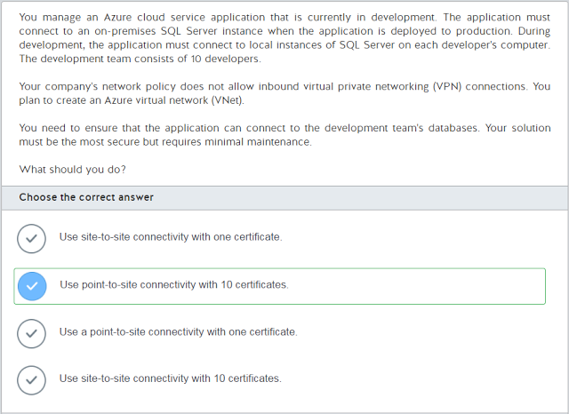](https://2.bp.blogspot.com/-i3XdZ7O7p20/WSCI3zFK2pI/AAAAAAAACcg/seToECqBCjs0LbwNf5KYUalr3CecF89PwCLcB/s1600/2017-05-20%2Bat%2B22-35-24.png)

[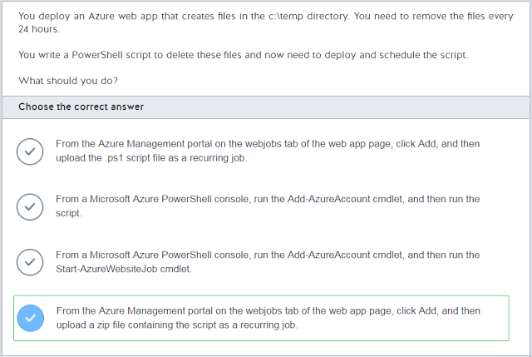](https://4.bp.blogspot.com/-vNAnV01ecZQ/WSCI4MbnQMI/AAAAAAAACck/9X7DaadXSDwo2WIalO8-S_ixW0UeQOWNwCLcB/s1600/2017-05-20%2Bat%2B22-35-45.png)

[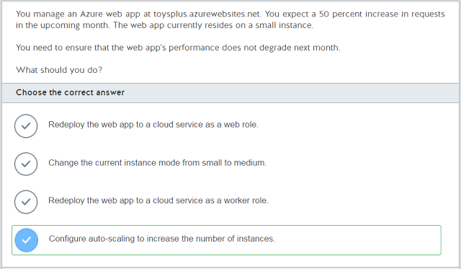](https://3.bp.blogspot.com/-DpWXUb8rDaw/WSCI4sFVCyI/AAAAAAAACcs/3BqNYu_K3pAbK0aIEqCbGzVCGLThHZwGQCLcB/s1600/2017-05-20%2Bat%2B22-36-00.png)

[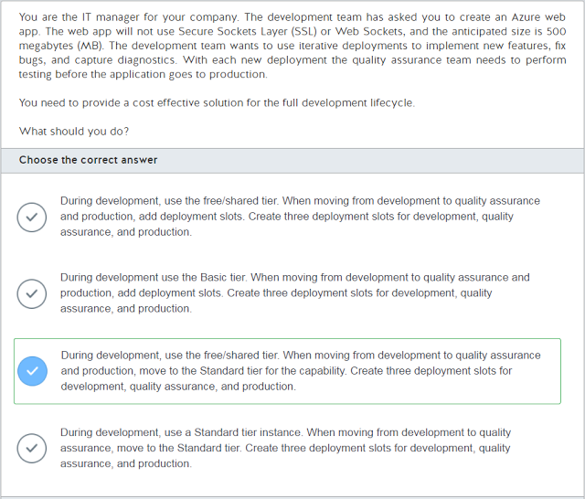](https://3.bp.blogspot.com/-9pdGW2HECsw/WSCI4oPMnTI/AAAAAAAACco/vCNQ3sgzPb8tZuycPlMHC_9Rrs4jnDSPwCLcB/s1600/2017-05-20%2Bat%2B22-36-16.png)

[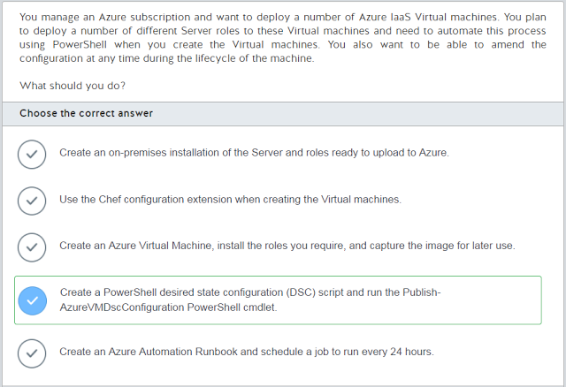](https://4.bp.blogspot.com/-bD1yDCGNNEk/WSCI491lZGI/AAAAAAAACcw/p_T1EYBKO-QuyzsQH3d6pATTPFaqyJkTwCLcB/s1600/2017-05-20%2Bat%2B22-36-31.png)

[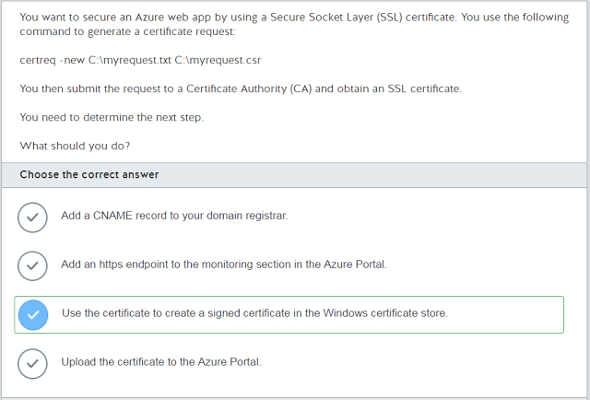](https://3.bp.blogspot.com/-Q9ZbjPsXY8g/WSCI5bIAybI/AAAAAAAACc0/dexo4FbmrogBa5wJ9BXkAH3C8ReX9R5XQCLcB/s1600/2017-05-20%2Bat%2B22-36-48.png)

[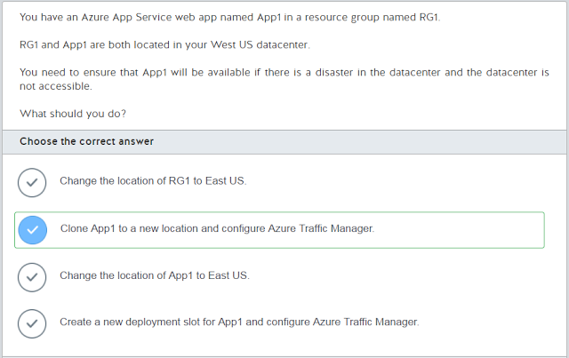](https://3.bp.blogspot.com/-H4YzKyKEQmA/WSCI5nOTEZI/AAAAAAAACc4/3Begca3OqsYycu8mv5TVKE3b1JKE6jdCgCLcB/s1600/2017-05-20%2Bat%2B22-37-01.png)

[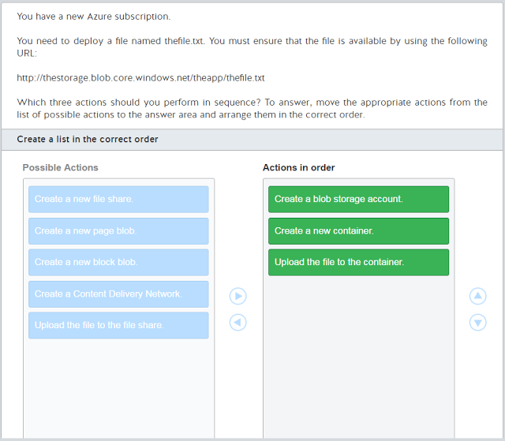](https://3.bp.blogspot.com/-9WET8EgwzkY/WSCI5gDaJMI/AAAAAAAACc8/XdSRHvzVvnk4q9S5WDqZfSvWNCfdsMirACLcB/s1600/2017-05-20%2Bat%2B22-37-15.png)

[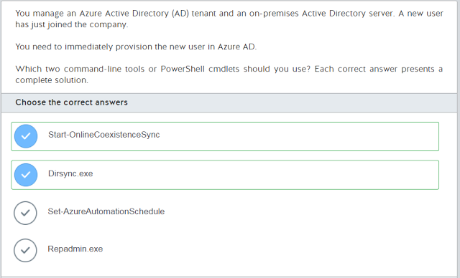](https://1.bp.blogspot.com/-YYAtLAmGMiQ/WSCI52WbTyI/AAAAAAAACdA/AZeCSHH1MEw3NKqq0y-4O0TJrzulF-uGACLcB/s1600/2017-05-20%2Bat%2B22-37-34.png)

[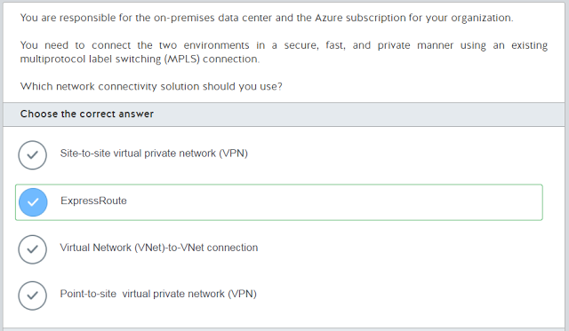](https://2.bp.blogspot.com/-ja7PYOSQh8E/WSCI6Tb83hI/AAAAAAAACdI/KzEu3roexxUY8nglOk0XWya7-dxhXNgpACLcB/s1600/2017-05-20%2Bat%2B22-38-05.png)

[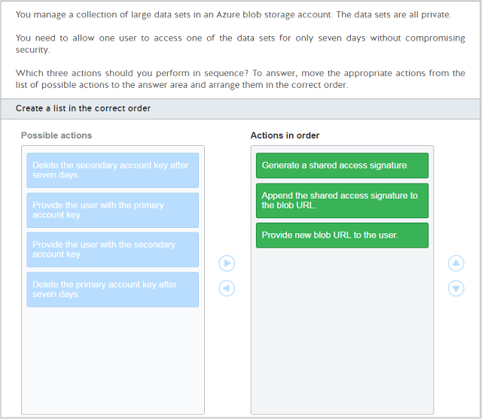](https://4.bp.blogspot.com/-FXRY8DQboZA/WSCI6YvEkNI/AAAAAAAACdE/ppqYa144t3kW_oVjn-W9ZWI8O5vNBI7nQCLcB/s1600/2017-05-20%2Bat%2B22-38-25.png)

[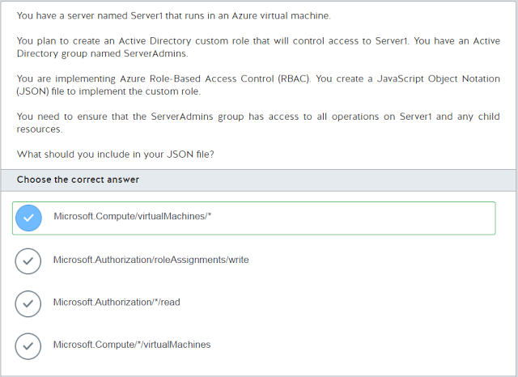](https://1.bp.blogspot.com/-33ipoIL0hLs/WSCI6S6sPkI/AAAAAAAACdM/25BTDKJr1xIRE1s1HKE6p9WwyX81S7_CQCLcB/s1600/2017-05-20%2Bat%2B22-38-50.png)

[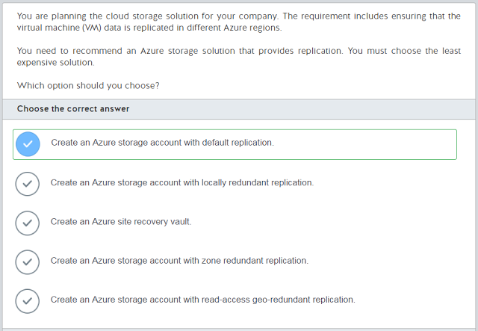](https://4.bp.blogspot.com/-VcLD7a7MShE/WSCI7F0wTpI/AAAAAAAACdQ/YrGs-5LQ2UsYNzgc0mpbt0_TslGGBabmQCLcB/s1600/2017-05-20%2Bat%2B22-39-08.png)

[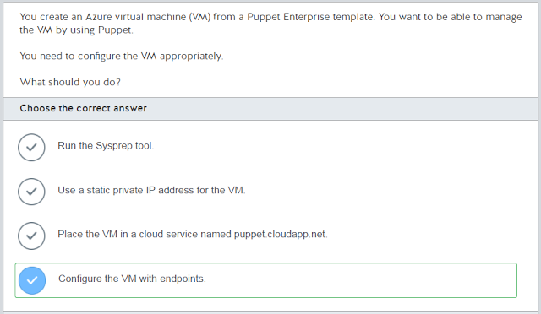](https://4.bp.blogspot.com/-eLE0ihNfo5g/WSCI7K27sAI/AAAAAAAACdU/hj6Cvv63KoEMg0liHlXj65aIOiWwELJdwCLcB/s1600/2017-05-20%2Bat%2B22-39-20.png)

[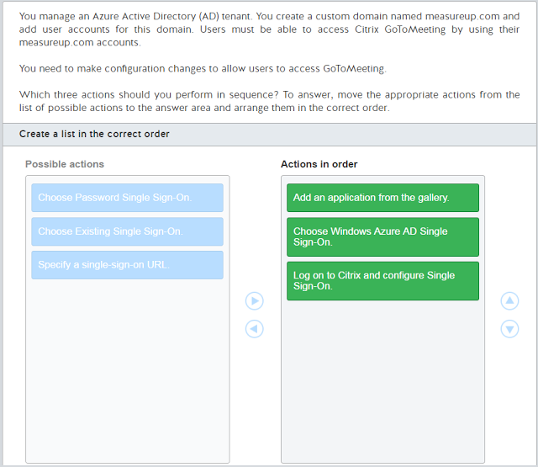](https://3.bp.blogspot.com/-luimYYBcQ4o/WSCI7Pv_PkI/AAAAAAAACdY/nnZ49odN_mQ_ajwjkSZn3e73cSSAmsUPgCLcB/s1600/2017-05-20%2Bat%2B22-41-07.png)

[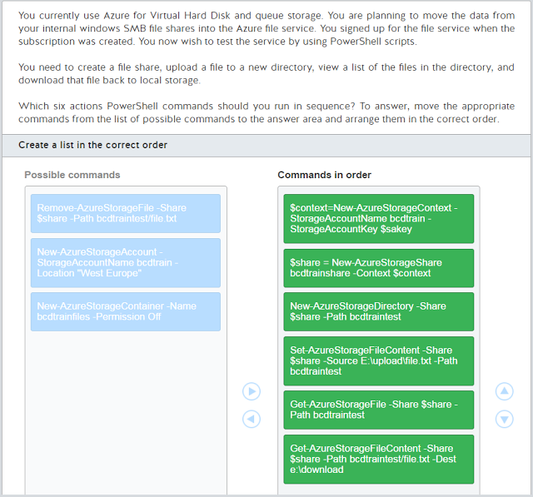](https://1.bp.blogspot.com/-YPTRF7fdJlY/WSCI73nGhJI/AAAAAAAACdc/pb7Ge34Nyc8ImSvKSvz-KSMdV5OQCA7qwCLcB/s1600/2017-05-20%2Bat%2B22-41-58.png)

[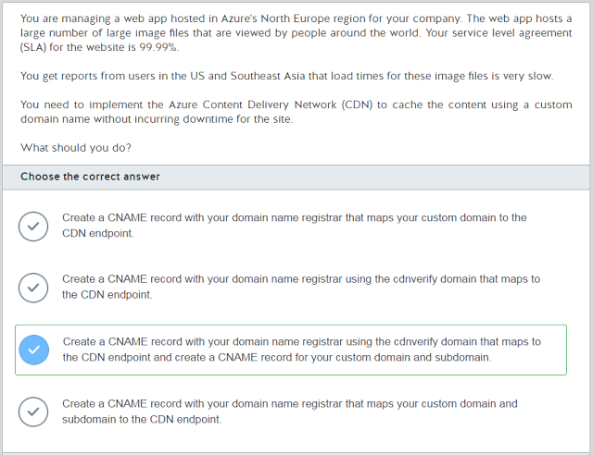](https://4.bp.blogspot.com/-BGv3NA-V9W8/WSCI8Cvv9SI/AAAAAAAACdg/Vljo1vhPXaE6QpfrFk5jJ6jZyE8jaehNACLcB/s1600/2017-05-20%2Bat%2B22-42-14.png)

[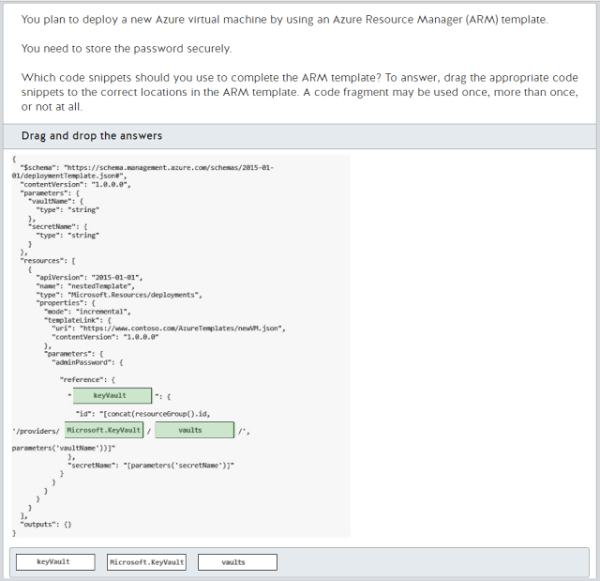](https://2.bp.blogspot.com/-7xhYElUx0sw/WSCI8SQadoI/AAAAAAAACdk/K4NXeAx3aW0MJERME-_wvoKpg0hGKdx4gCLcB/s1600/2017-05-20%2Bat%2B22-42-54.png)

[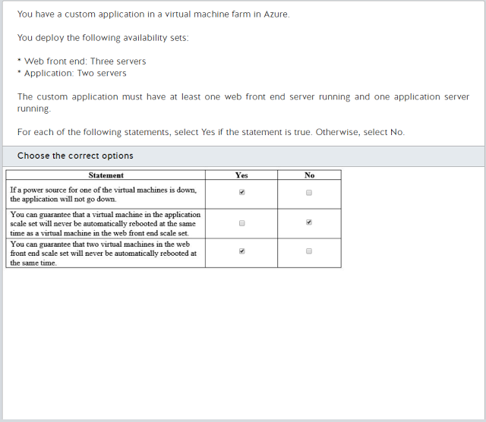](https://3.bp.blogspot.com/-ZHx0WwvigVA/WSCI8qxiZtI/AAAAAAAACdo/uIunm9F90kURjoOaTJT3nrcByY_q13IJACLcB/s1600/2017-05-20%2Bat%2B22-43-11.png)

[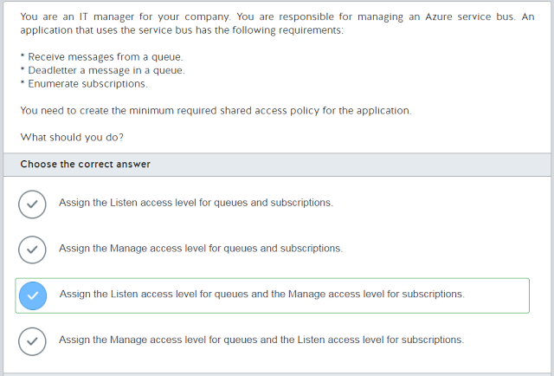](https://1.bp.blogspot.com/-vvxin_rCLLQ/WSCI8x5HpcI/AAAAAAAACds/_3PN0Pm66awxP6hSWSPhE1IQJ5sQyKrDgCLcB/s1600/2017-05-20%2Bat%2B22-43-28.png)

[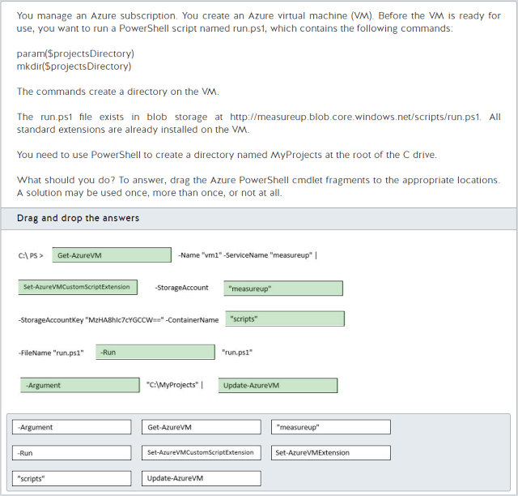](https://4.bp.blogspot.com/-Fs4dtlVIxRE/WSCI9Ex4jEI/AAAAAAAACdw/zlgjwoKKA2cMusGcCQbYvSWMhCdr8TrFgCLcB/s1600/2017-05-20%2Bat%2B22-44-00.png)

[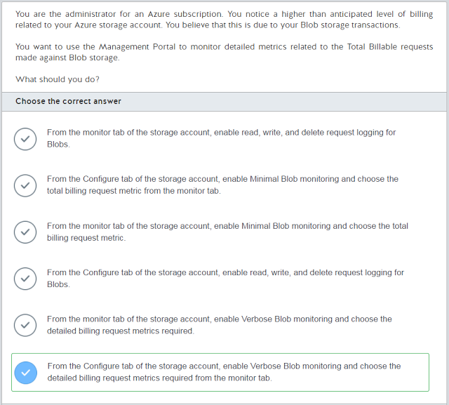](https://3.bp.blogspot.com/-45pT9YBrV5s/WSCI9Xl59lI/AAAAAAAACd0/lF88Y0ngD5kF9OcDkif94Ge1uVHoDRMAQCLcB/s1600/2017-05-20%2Bat%2B22-44-20.png)

[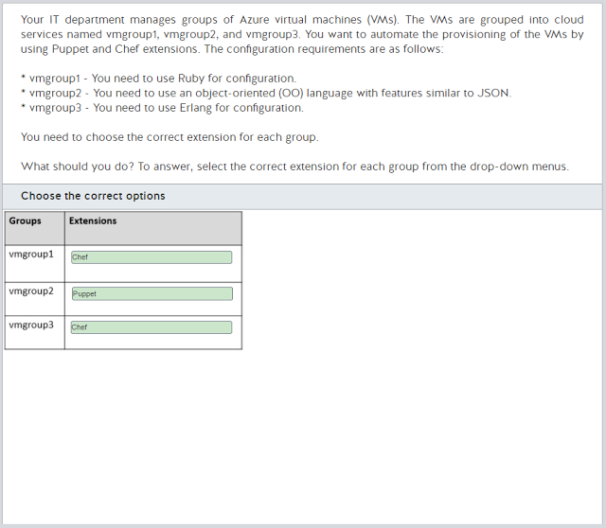](https://2.bp.blogspot.com/-UHMU0Zs60_Y/WSCI9r7qYZI/AAAAAAAACd4/3uRfMU6jgEAPDtHXQw1DHoHey20HZI2gACLcB/s1600/2017-05-20%2Bat%2B22-44-38.png)

[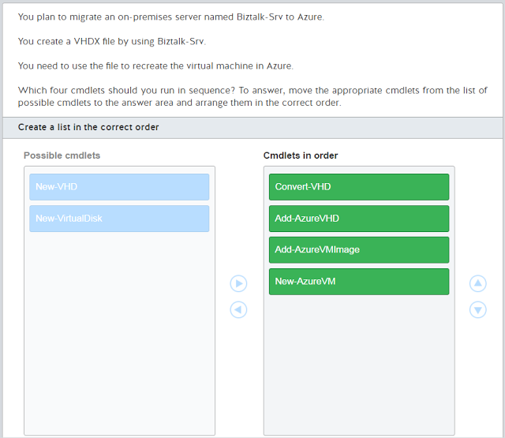](https://4.bp.blogspot.com/-E9q6WHiBsS0/WSCI9zjIQaI/AAAAAAAACd8/eE25CZ7GAjsQs4BOBryymdBbck_yyExFgCLcB/s1600/2017-05-20%2Bat%2B22-50-02.png)

[](https://2.bp.blogspot.com/-AuClZes2Wyw/WSCI90fRRsI/AAAAAAAACeA/7vAWd3avZgcd45o81ubFs9m2ZIZuB-dDQCLcB/s1600/2017-05-20%2Bat%2B22-50-26.png)

[](https://1.bp.blogspot.com/-_bw8wubrj88/WSCI-HuZZyI/AAAAAAAACeE/sC6Ms7XWy5AJ4E2i1c_QmS0Y9CoHYcDPgCLcB/s1600/2017-05-20%2Bat%2B22-50-42.png)

[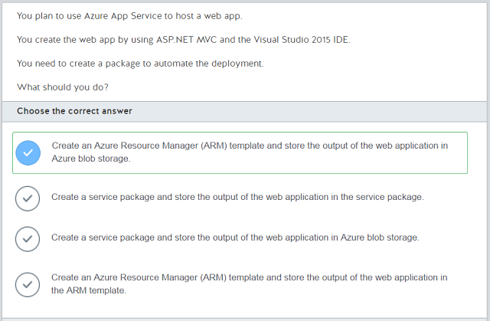](https://3.bp.blogspot.com/-jcTKFfghi-I/WSCI-b0M0DI/AAAAAAAACeI/7CQBiZVUZF0ITvJIbr53eqTGtxXTjgmuwCLcB/s1600/2017-05-20%2Bat%2B22-51-04.png)

[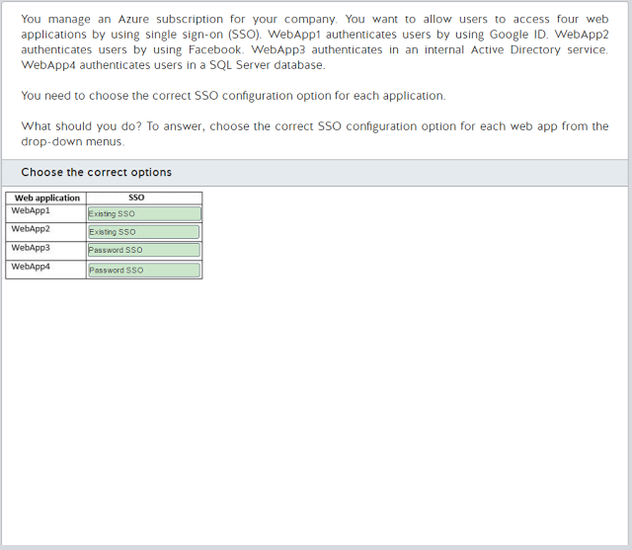](https://4.bp.blogspot.com/-MldAsZoUKIk/WSCI-tCJwbI/AAAAAAAACeM/AF48q2lOL140SC0hwqeSAWqHh4ySY7RpwCLcB/s1600/2017-05-20%2Bat%2B22-51-20.png)

[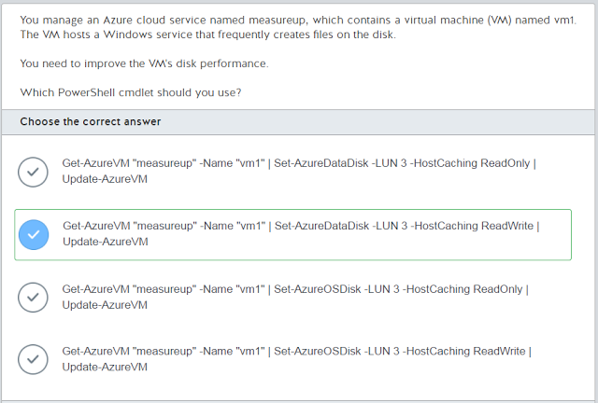](https://2.bp.blogspot.com/-6ShtrJbKlnA/WSCI-xJGTZI/AAAAAAAACeQ/_KE9pRk67nkCGWZKVA53Oz1_vuSXVx1hgCLcB/s1600/2017-05-20%2Bat%2B22-51-34.png)

[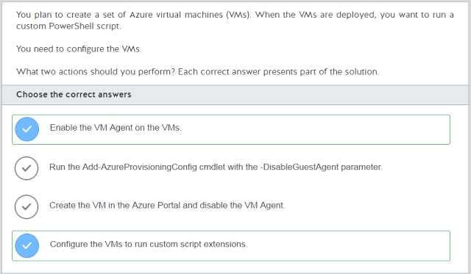](https://3.bp.blogspot.com/-kAFtShGWDYM/WSCI_Ob55zI/AAAAAAAACeU/PgK9X4z5HMA88qWFXd6W_5jte9Wg9r01gCLcB/s1600/2017-05-20%2Bat%2B22-51-54.png)

[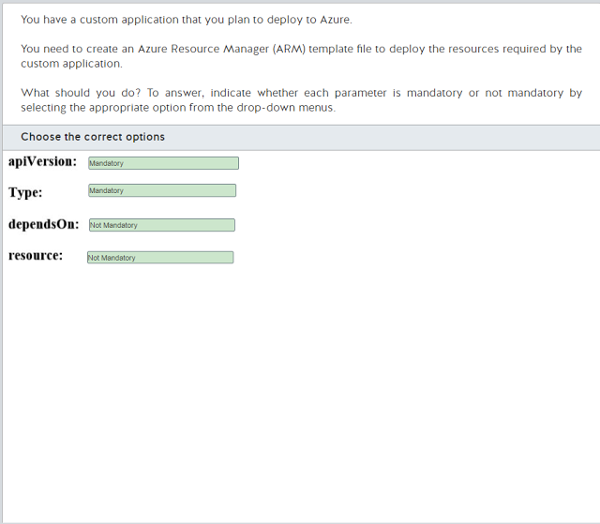](https://3.bp.blogspot.com/-tDxImvPcBDw/WSCI_dR3SHI/AAAAAAAACeY/Am9LLoxykG41c7-w7Irg0d2A4jrx3NYqQCLcB/s1600/2017-05-20%2Bat%2B22-52-15.png)

[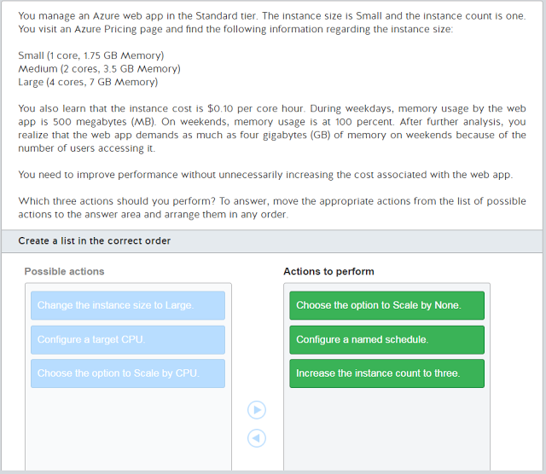](https://1.bp.blogspot.com/-L6V4Qe9FawA/WSCI_g3SZjI/AAAAAAAACec/G32t4n4v_g4x2hcostTi6uZ7dweztShxQCLcB/s1600/2017-05-20%2Bat%2B22-52-29.png)

[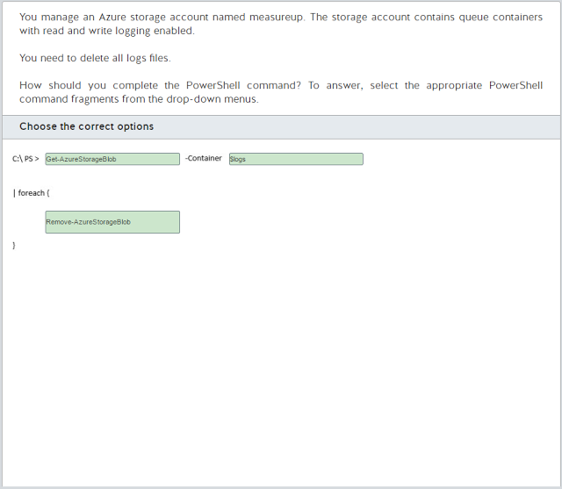](https://1.bp.blogspot.com/-t6tBcssL6xY/WSCI_r6V6uI/AAAAAAAACeg/nNA_cuoH8SQqlnbmhy6XOta87ZQYL63BACLcB/s1600/2017-05-20%2Bat%2B22-52-42.png)

[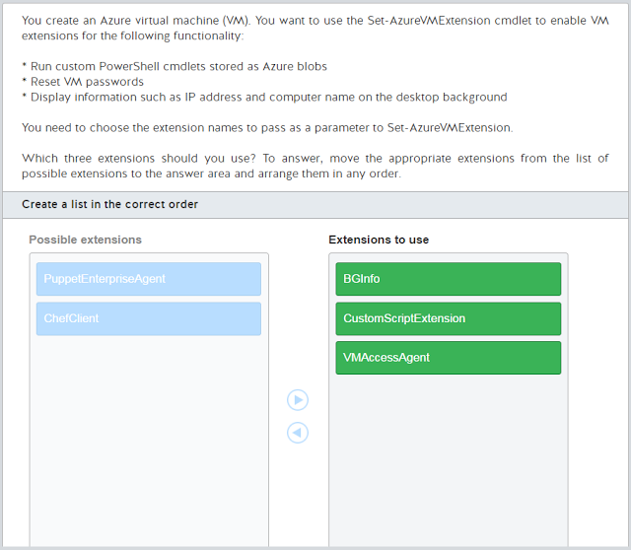](https://2.bp.blogspot.com/-xpn-5Y2I_Ss/WSCJAH9D-QI/AAAAAAAACek/U8U-4RuePts7NRP0Kkz9CdwRdiQe9vF0wCLcB/s1600/2017-05-20%2Bat%2B22-53-00.png)

[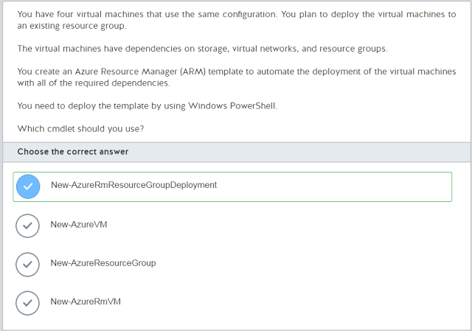](https://4.bp.blogspot.com/--87zdRC0xN4/WSCJAYGvWvI/AAAAAAAACeo/xkp4afzp-i0XnPCzMn8Gp6UkvTjDPuB5ACLcB/s1600/2017-05-20%2Bat%2B22-53-16.png)

[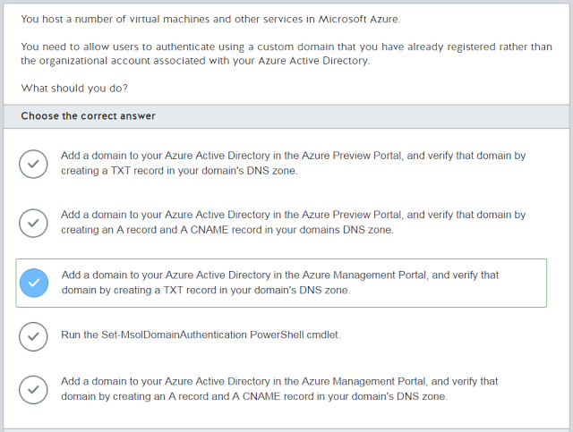](https://3.bp.blogspot.com/-QvwdO3lADQU/WSCJAS0n0QI/AAAAAAAACes/6Otr1CTYheg0i2YGyW339-0CDb4dMnMWQCLcB/s1600/2017-05-20%2Bat%2B22-54-48.png)

[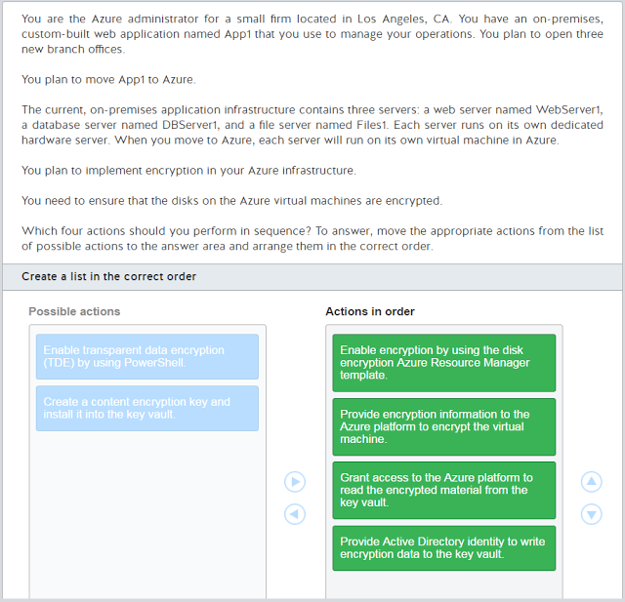](https://4.bp.blogspot.com/-QXayJoTSQXg/WSCJAuRugoI/AAAAAAAACew/5WLq48DFwmo4naOOLN40fp9PxNkqRf2cgCLcB/s1600/2017-05-20%2Bat%2B22-55-15.png)

[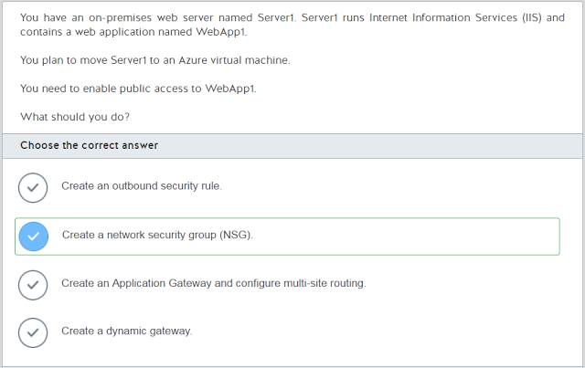](https://3.bp.blogspot.com/-tMoasYHZroM/WSCJA7F19_I/AAAAAAAACe0/bmwXG7B6318mZpRIXyi5CozADC-0Vnh2wCLcB/s1600/2017-05-20%2Bat%2B22-55-32.png)

[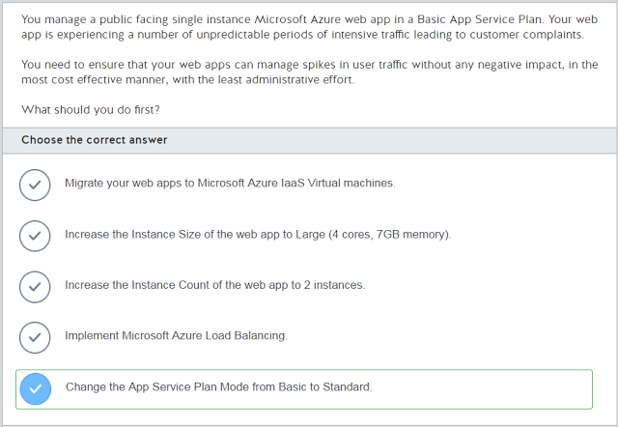](https://4.bp.blogspot.com/-n2LA-xYRO34/WSCJBOQCoWI/AAAAAAAACe4/AnvC_HeKHlQI1N_cihUYhaxJek_dNhjlQCLcB/s1600/2017-05-20%2Bat%2B22-57-14.png)

[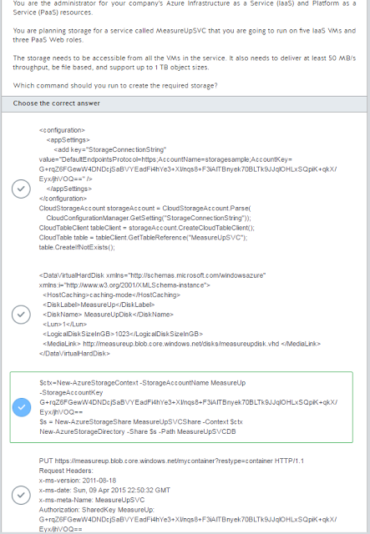](https://1.bp.blogspot.com/-da17h1g56N4/WSCJBiN41uI/AAAAAAAACfE/hijFBAdsctEoNu2TY4q03bEKIO3jXSd6gCLcB/s1600/2017-05-20%2Bat%2B22-58-10.png)

[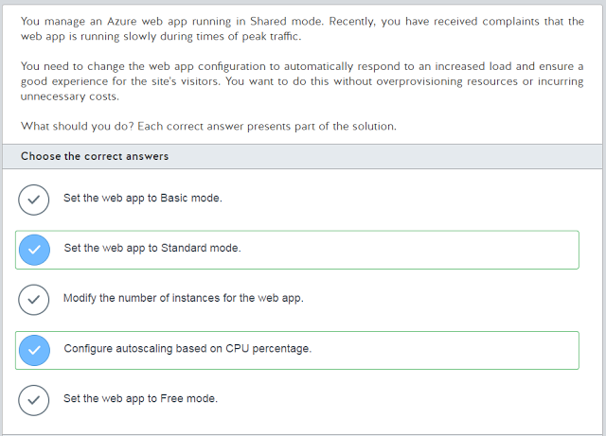](https://3.bp.blogspot.com/-v6FLyGE53nU/WSCJBVdpW_I/AAAAAAAACe8/S_dhHLisl3cII70hcAl8d8AyAeLyTpvEgCLcB/s1600/2017-05-20%2Bat%2B22-58-36.png)

[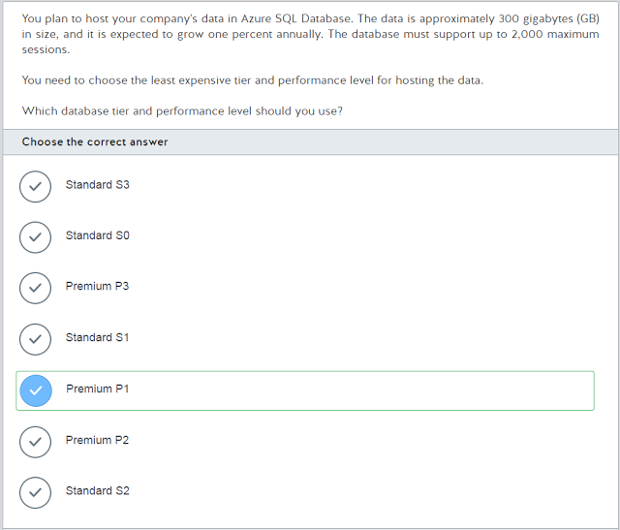](https://3.bp.blogspot.com/-uVVyawz_k24/WSCJBrK54II/AAAAAAAACfA/2B5CrORcbhUD7Y_3pgzHck4P1Em3naPEQCLcB/s1600/2017-05-20%2Bat%2B22-58-58.png)

[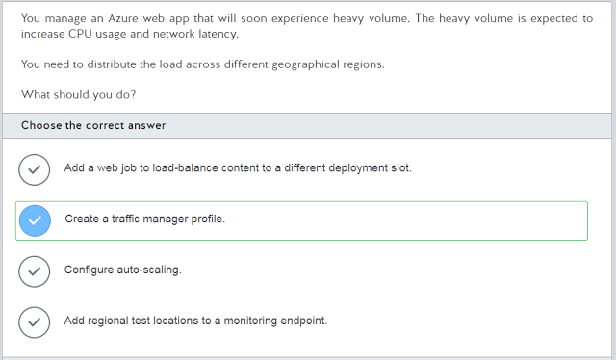](https://4.bp.blogspot.com/-PpQWImgj2Iw/WSCJB_El0KI/AAAAAAAACfI/IYSvf-pxsm4xe1_URMam6CqQIODkvtgBQCLcB/s1600/2017-05-20%2Bat%2B22-59-22.png)

[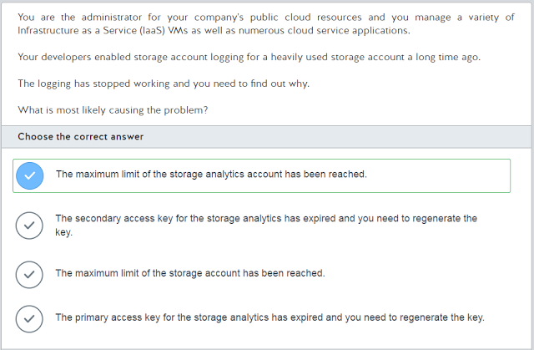](https://2.bp.blogspot.com/-6SZMuBFulbQ/WSCJCL8ci8I/AAAAAAAACfM/4xSMNaXGuqw0b4gQ934cOQ1Qj5oX3Mf9ACLcB/s1600/2017-05-20%2Bat%2B23-00-08.png)

[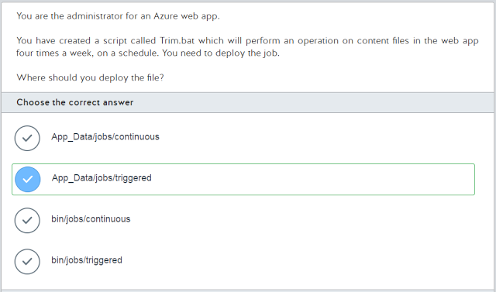](https://4.bp.blogspot.com/-I5LOEc1rrfA/WSCJCFjFI8I/AAAAAAAACfQ/YvsVgbzeIUI9FXgWW7rKot0Ck2j6BHMmQCLcB/s1600/2017-05-20%2Bat%2B23-00-28.png)

[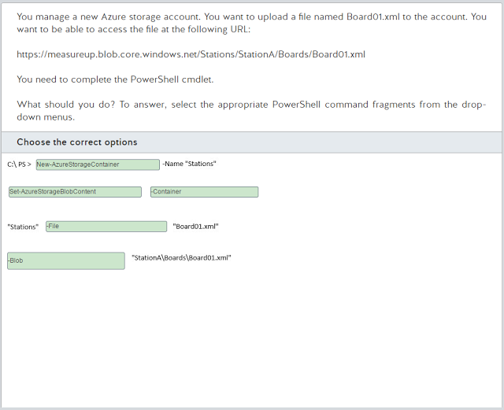](https://3.bp.blogspot.com/-3JUJTvjOwa8/WSCJC2GsQvI/AAAAAAAACfc/jn7RUIkx8MwBeBf_EaidcOym7br_gNFvwCLcB/s1600/2017-05-20%2Bat%2B23-00-52.png)

[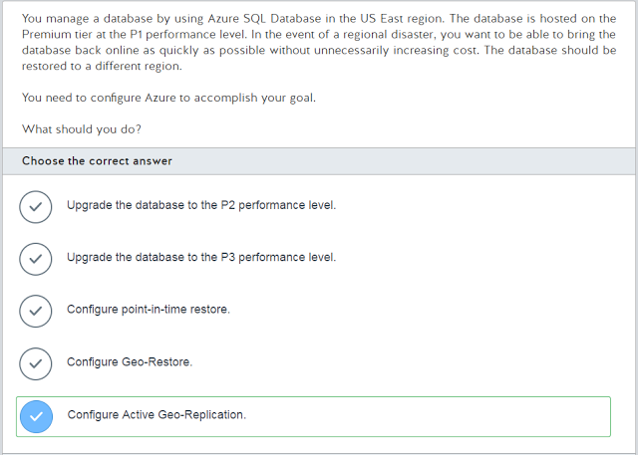](https://2.bp.blogspot.com/-oootMJmpywY/WSCJCqickcI/AAAAAAAACfU/1OlvdxYJ0tk-jxm2PIiOvKMVtnm1X0M2gCLcB/s1600/2017-05-20%2Bat%2B23-01-15.png)

[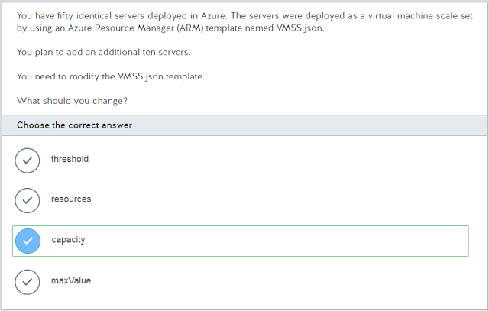](https://1.bp.blogspot.com/-K2FkcuIrOcU/WSCJCroqmvI/AAAAAAAACfY/61EMAfeb_7w8i9m5D63VoODFYoU81XzEgCLcB/s1600/2017-05-20%2Bat%2B23-01-36.png)

[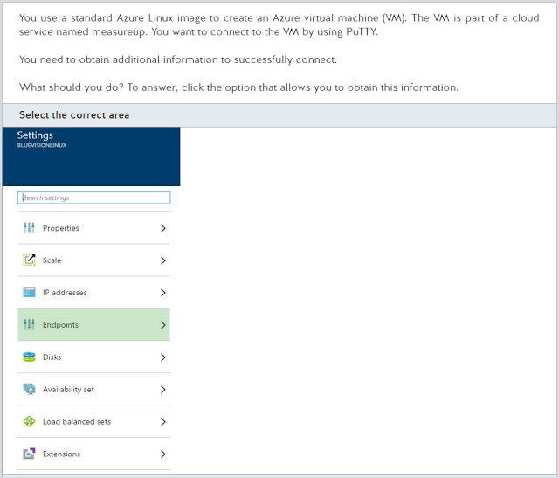](https://4.bp.blogspot.com/-Wp9dnh0mY3I/WSCJDMDNlmI/AAAAAAAACfg/zH8scA3w2Oo_MA-zI-4YKSKgqR6Dj_HPwCLcB/s1600/2017-05-20%2Bat%2B23-02-07.png)

[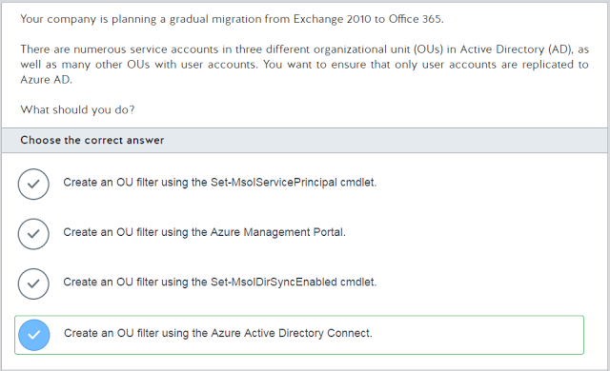](https://1.bp.blogspot.com/-jVl_evv45oE/WSCJDW1JpMI/AAAAAAAACfk/nvCGlGDjykUWfO-AKapR1ZVgm3NG7XS9gCLcB/s1600/2017-05-20%2Bat%2B23-02-33.png)

[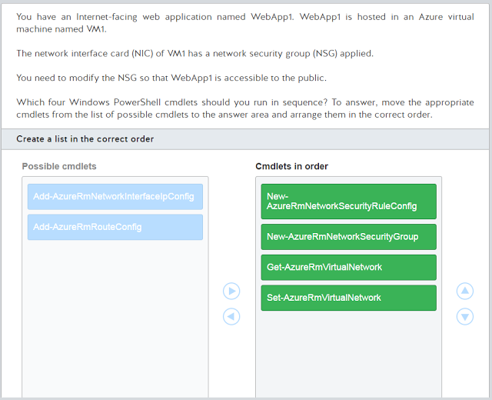](https://2.bp.blogspot.com/-ijYn5PDG5OE/WSCJDdJVTWI/AAAAAAAACfo/n192uT3EadQQVmPceeHMPFaucoXomUo6wCLcB/s1600/2017-05-20%2Bat%2B23-02-59.png)

[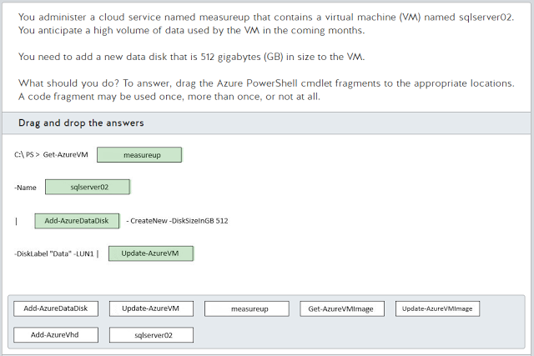](https://4.bp.blogspot.com/-IzMwLcJLL6E/WSCJED_ZQiI/AAAAAAAACf0/YCJrb-rEuhkvkEkf3p8cL1KJmsd4dNSnACLcB/s1600/2017-05-20%2Bat%2B23-03-19.png)

[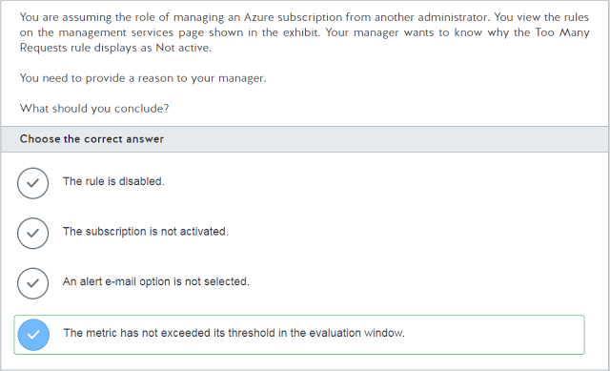](https://4.bp.blogspot.com/-OcDqtfTLRis/WSCJD_g2XMI/AAAAAAAACfs/QXCS4EIO-PgJ0s5euxQRU3pky0PkFZiaQCLcB/s1600/2017-05-20%2Bat%2B23-03-55.png)

[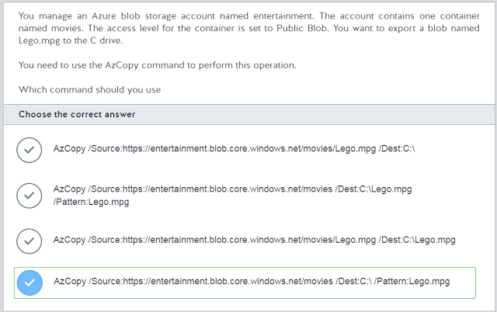](https://1.bp.blogspot.com/-Y5ItEdkLQUM/WSCJELl5yuI/AAAAAAAACfw/8xf2OtmVtJwIn7Nzn57eyaQCZoFKKloZgCLcB/s1600/2017-05-20%2Bat%2B23-04-13.png)

[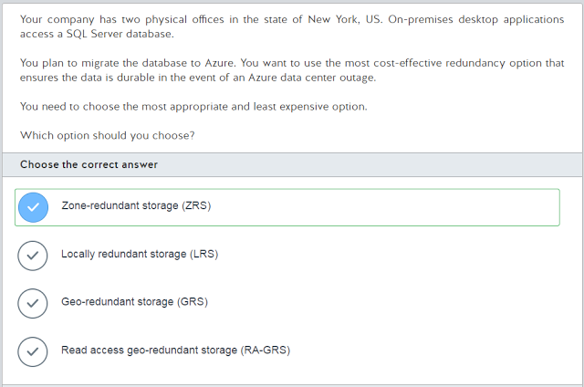](https://2.bp.blogspot.com/-5Ad2KbVA--A/WSCJEmzdAaI/AAAAAAAACf8/z9Q1zqHu9jocNh6HLLYVb7-pf_B_J2qbwCLcB/s1600/2017-05-20%2Bat%2B23-04-34.png)

[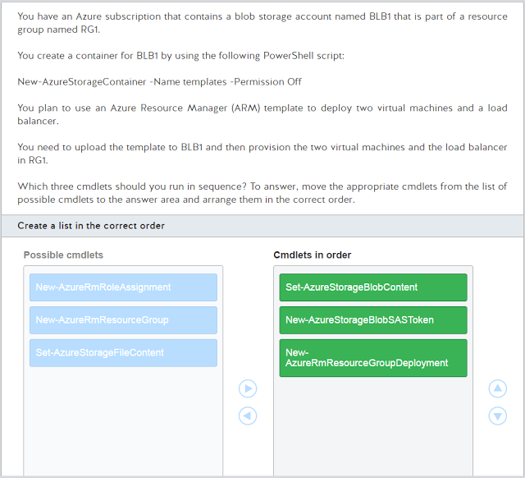](https://4.bp.blogspot.com/-TBhPKLJuXOM/WSCJEoCF2LI/AAAAAAAACgA/EEGiAlyuekoz5XuBiSmff_JZqvGVCCpigCLcB/s1600/2017-05-20%2Bat%2B23-05-36.png)

[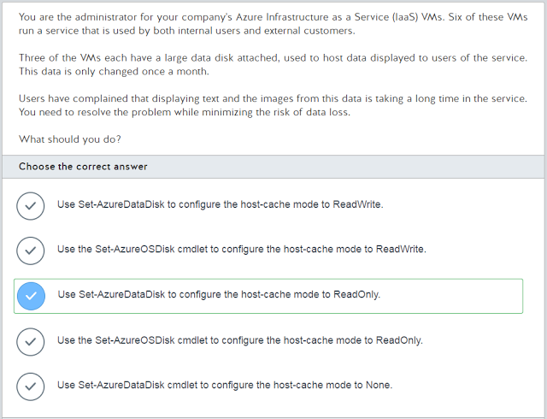](https://4.bp.blogspot.com/-mGgqpQQ7RnQ/WSCJEkra3lI/AAAAAAAACf4/99uGBxEeinMvDC6ViT2MhHMLksPyAQJnwCLcB/s1600/2017-05-20%2Bat%2B23-05-57.png)

[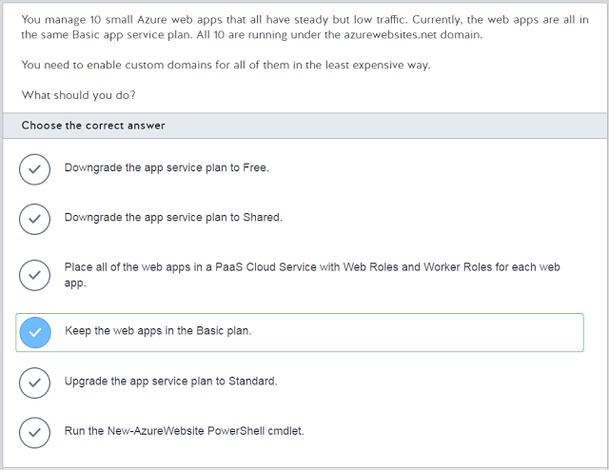](https://1.bp.blogspot.com/-06AWaAFWm1s/WSCJFG5y-aI/AAAAAAAACgE/pJ__yYMiHm039-tiC6ZvXrH-JTrGRrbagCLcB/s1600/2017-05-20%2Bat%2B23-11-58.png)

[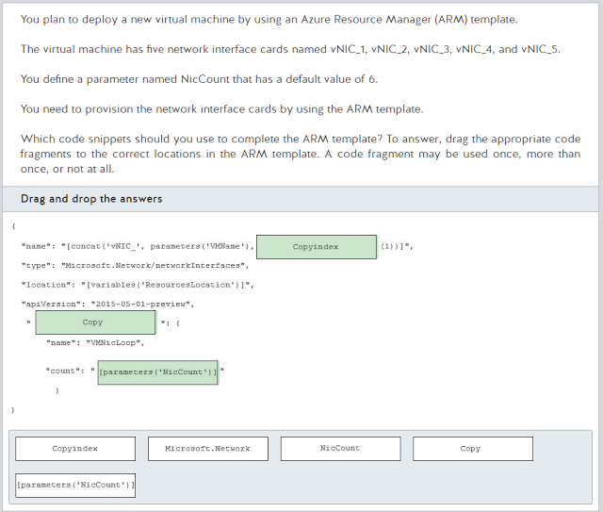](https://4.bp.blogspot.com/-E0CS7jd_De8/WSCJFQe7p0I/AAAAAAAACgM/D_BnHpiipig3d7stuv2X-dHwIe961VuJwCLcB/s1600/2017-05-20%2Bat%2B23-12-39.png)

[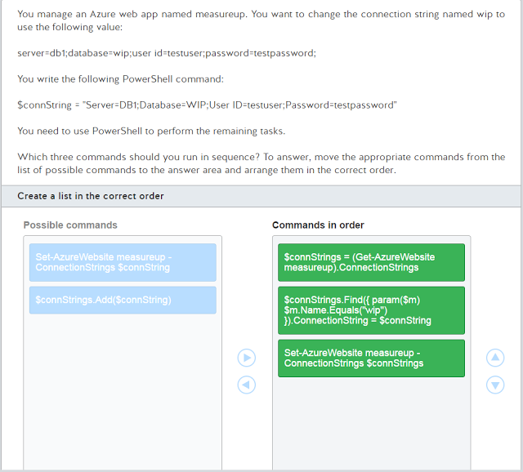](https://2.bp.blogspot.com/-7FHWRR6_l80/WSCJFWiMBAI/AAAAAAAACgI/ft9JI4NKobMvVL7IbCKCuX_ggawGUMyXQCLcB/s1600/2017-05-20%2Bat%2B23-13-25.png)

[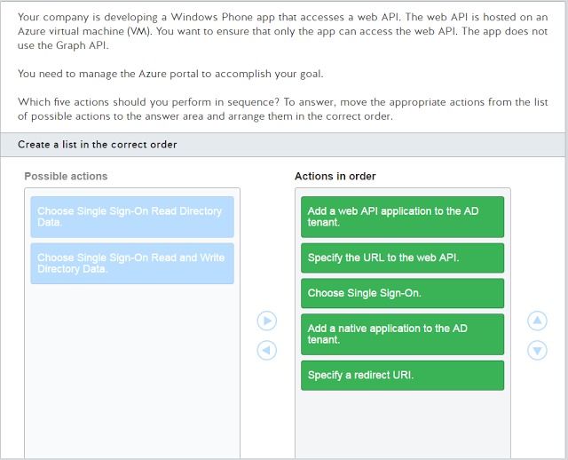](https://2.bp.blogspot.com/-0YZxQcMfgk0/WSCJGCZTptI/AAAAAAAACgU/qV-TggVEHHMv8bPerimGL6uJFEyOurOMwCLcB/s1600/2017-05-20%2Bat%2B23-13-41.png)

[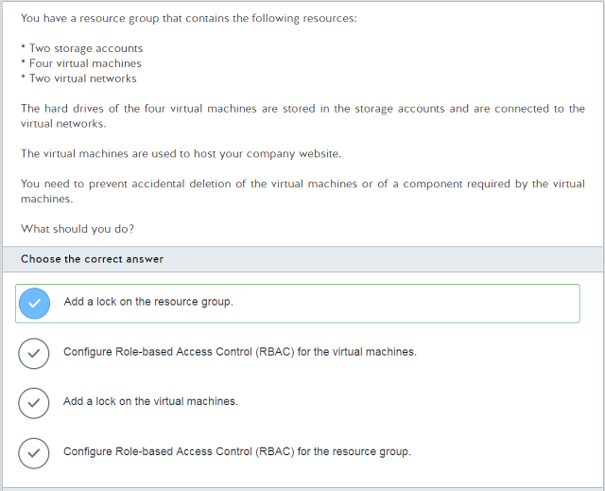](https://2.bp.blogspot.com/-qDgXFcBhNAs/WSCJF4soeOI/AAAAAAAACgQ/PqtTi_cZzxQDDNbhKXfAl271AXwEIdrNACLcB/s1600/2017-05-20%2Bat%2B23-13-59.png)

[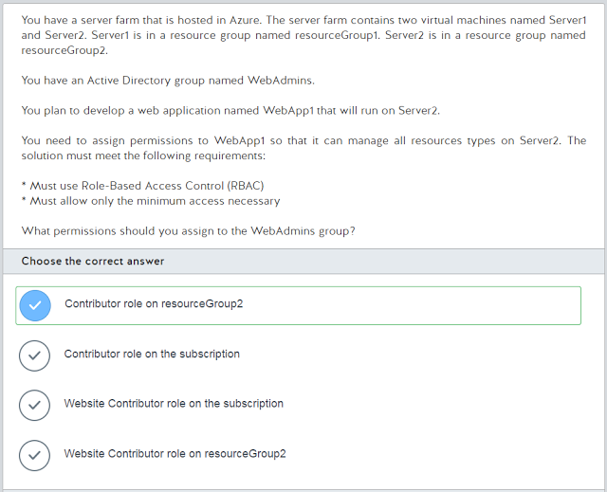](https://3.bp.blogspot.com/-oTMZaCWrnro/WSCJGNvyILI/AAAAAAAACgY/UTlLwlqb9Q0uLMUHgfcHgl5NF931TXNWACLcB/s1600/2017-05-20%2Bat%2B23-14-16.png)

[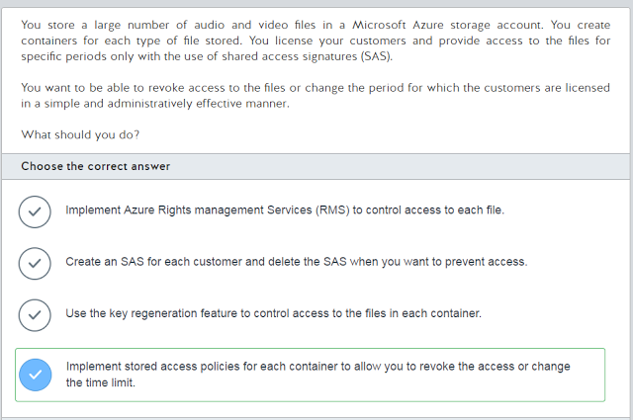](https://2.bp.blogspot.com/-ryNXAC1ATEE/WSCJGh3lPUI/AAAAAAAACgc/wqFoO4RoyEUgThx19Givbf_SnLgAlrOpgCLcB/s1600/2017-05-20%2Bat%2B23-14-32.png)

[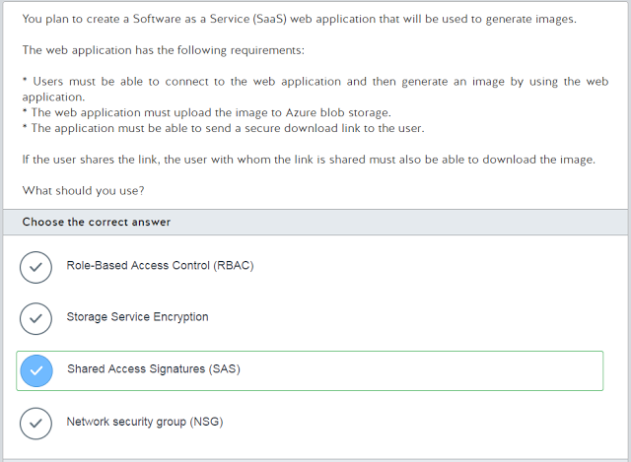](https://1.bp.blogspot.com/-8xiOiyNdc1c/WSCJG5DmPwI/AAAAAAAACgk/UY6wnIdFMboU_nz2z4FTQXow9F2xAA_1ACLcB/s1600/2017-05-20%2Bat%2B23-14-50.png)

[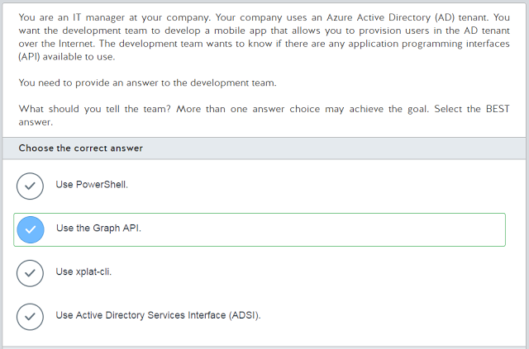](https://1.bp.blogspot.com/-7PBT7gha-As/WSCJG-fAcWI/AAAAAAAACgg/lL_2mGcbctAqcxfdC3LGnvkYnl5EOClJgCLcB/s1600/2017-05-20%2Bat%2B23-15-04.png)

[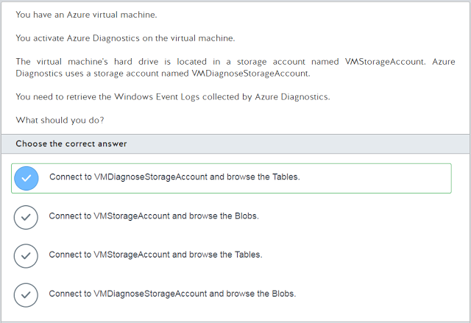](https://3.bp.blogspot.com/-kNoAbAYmobA/WSCJHCtpsZI/AAAAAAAACgo/851HLWC8kCwm0pFut1Gj3MOfuAdH18ZRACLcB/s1600/2017-05-20%2Bat%2B23-15-20.png)

[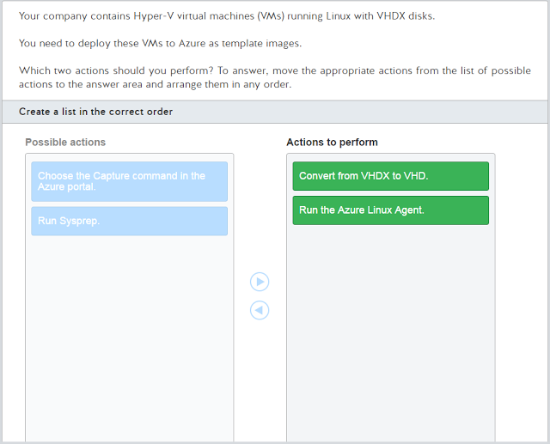](https://4.bp.blogspot.com/-dCV9VER1vd0/WSCJHYS6ITI/AAAAAAAACgs/KDrlmZXIYAkAVP8AvnJCNCWBaw0iPU04QCLcB/s1600/2017-05-20%2Bat%2B23-15-33.png)

[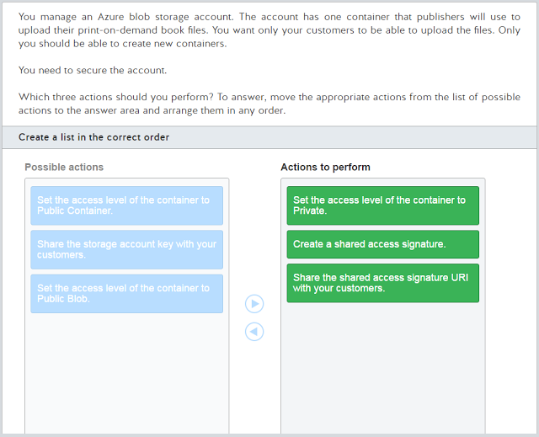](https://3.bp.blogspot.com/-KhGAk-lCH9M/WSCJHijf8OI/AAAAAAAACgw/yfhYrtppEHQTpBF3QQn76Omzj-QN9NMjQCLcB/s1600/2017-05-20%2Bat%2B23-15-52.png)

[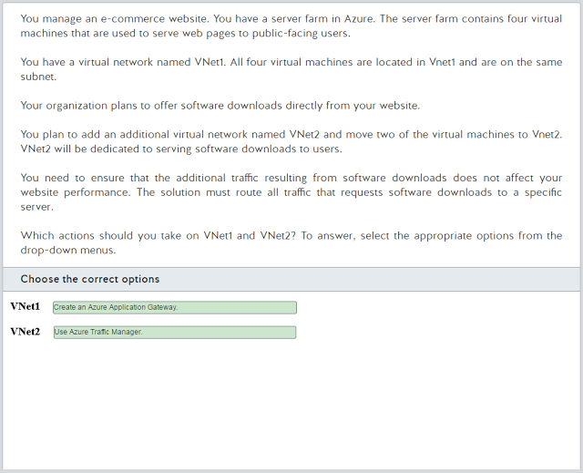](https://2.bp.blogspot.com/-xIaPcN0SmCs/WSCJHgGgSlI/AAAAAAAACg0/S6OfQk1rAJYywvRDwPitC-epPvgFiPDUACLcB/s1600/2017-05-20%2Bat%2B23-16-17.png)

[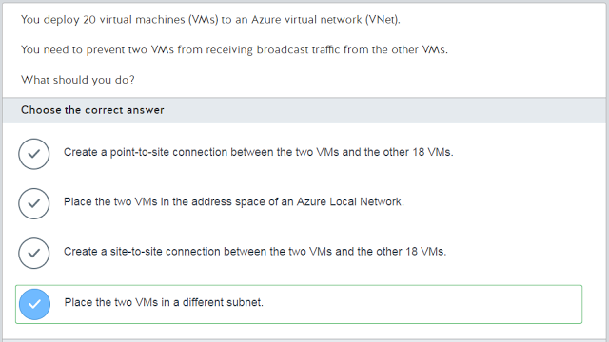](https://1.bp.blogspot.com/-XHqQ3le2L0A/WSCJIBdFEBI/AAAAAAAACg4/a11G775I_dUUWwUGQVa3JfgzqfA2fKXywCLcB/s1600/2017-05-20%2Bat%2B23-16-38.png)

[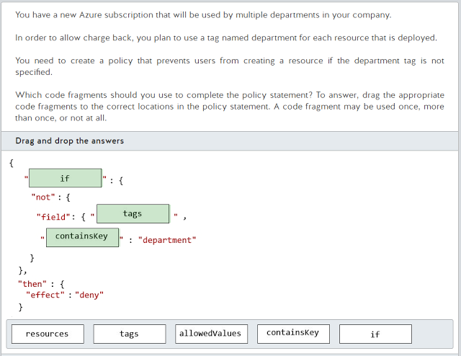](https://1.bp.blogspot.com/-dwcO_SZMvQY/WSCJIRNvfsI/AAAAAAAAChA/UVOFTcqJaDoR-qysYCbGmw53m4phZSfEQCLcB/s1600/2017-05-20%2Bat%2B23-16-54.png)

[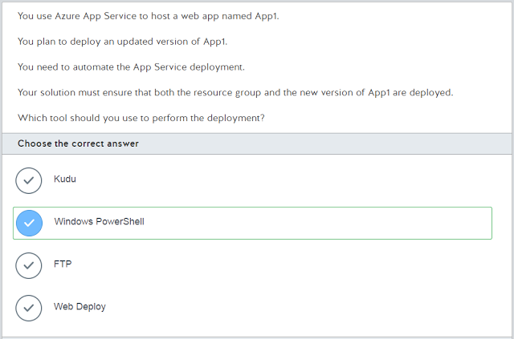](https://3.bp.blogspot.com/-GrbSRYYVYno/WSCJIZWLpyI/AAAAAAAACg8/sPUiKdJrnMwAz8cNftd3G9n1q-d6I3yaACLcB/s1600/2017-05-20%2Bat%2B23-17-07.png)

[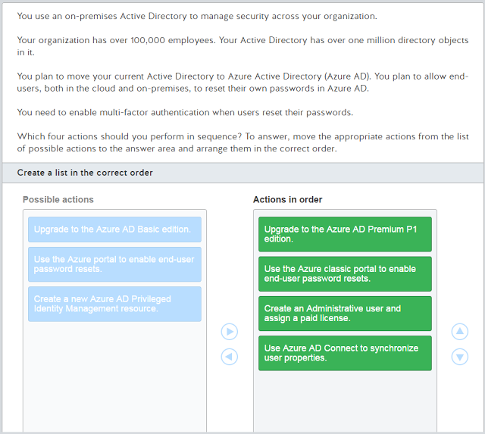](https://1.bp.blogspot.com/-_VR3UH9x1DY/WSCJIpr6AMI/AAAAAAAAChE/koXQZQ0wEwgH2vvICkE41W1VFv50f_rjwCLcB/s1600/2017-05-20%2Bat%2B23-17-26.png)

[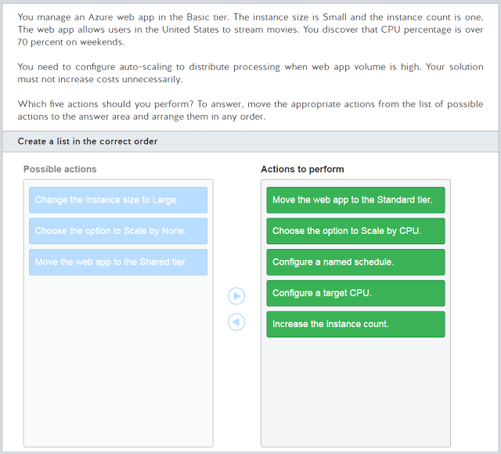](https://2.bp.blogspot.com/-G07rGv7mrSA/WSCJJBGlI1I/AAAAAAAAChM/qBDRjYyo4MMs688Vpilto9z334BWgr3ZACLcB/s1600/2017-05-20%2Bat%2B23-17-48.png)

[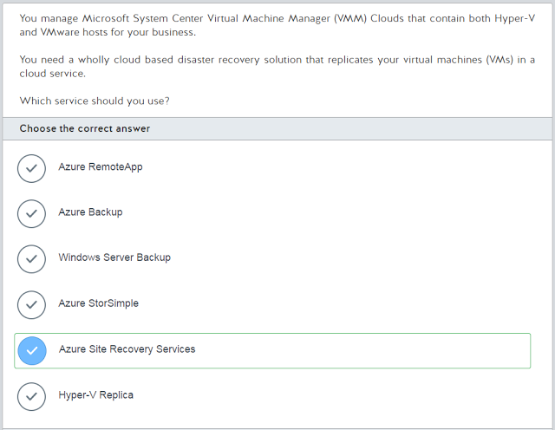](https://2.bp.blogspot.com/-M9ep4gsZqM8/WSCJJEB5WpI/AAAAAAAAChI/PMidP0nxqOgn8JkH_mR-eUSccICnkqEzACLcB/s1600/2017-05-20%2Bat%2B23-18-07.png)

[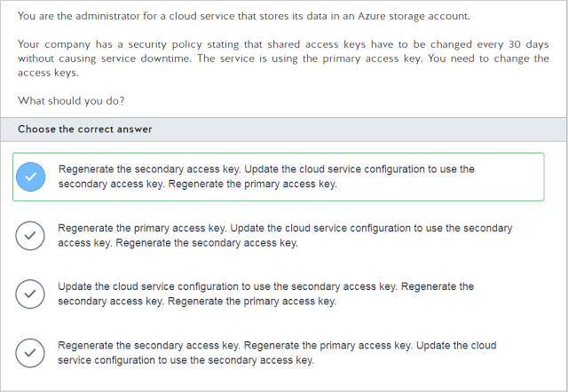](https://2.bp.blogspot.com/-hYncUF-GsTo/WSCJJfL6eFI/AAAAAAAAChQ/qoFog2zt65Iau4C5siVQvsluYaWBEuolQCLcB/s1600/2017-05-20%2Bat%2B23-18-23.png)

[](https://1.bp.blogspot.com/-gWltNUdUJnc/WSCJKBFy7OI/AAAAAAAAChY/hE9ZOxq8_Dc1XD5AODAF8uL_gGXwXVTOACLcB/s1600/2017-05-20%2Bat%2B23-18-43.png)

[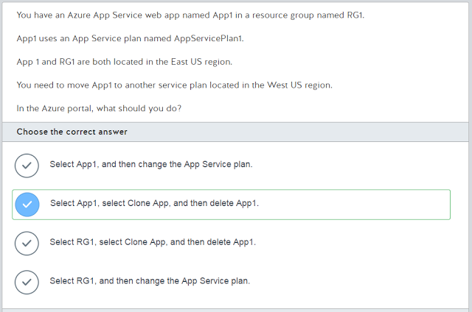](https://4.bp.blogspot.com/-RqZSd8EUcwo/WSCJKBY2vCI/AAAAAAAAChU/I6vU9uSz4D0hiT8ONfRxRs7HqOdFa4amACLcB/s1600/2017-05-20%2Bat%2B23-19-07.png)

[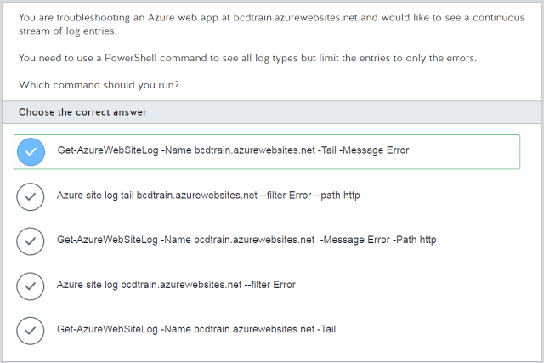](https://3.bp.blogspot.com/-jIOXbYlXOc4/WSCJKMWqVYI/AAAAAAAAChc/pv2uHImBSOE2VYBTzeF8zZuJBVHqzedHgCLcB/s1600/2017-05-20%2Bat%2B23-19-32.png)

[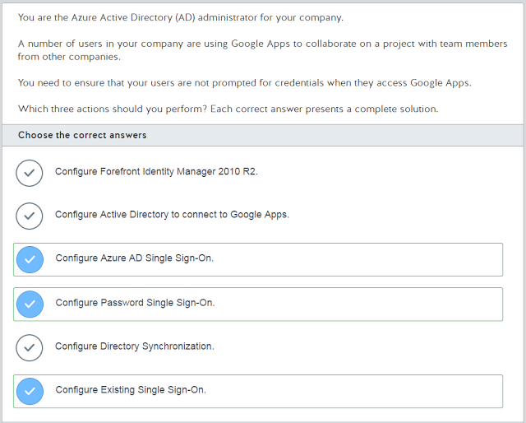](https://1.bp.blogspot.com/-qnIqU21iF1E/WSCJK4ZiPfI/AAAAAAAAChg/DNUnhgy7aBAJeSNJBNIABLSwCLJZPUJfgCLcB/s1600/2017-05-20%2Bat%2B23-19-48.png)

[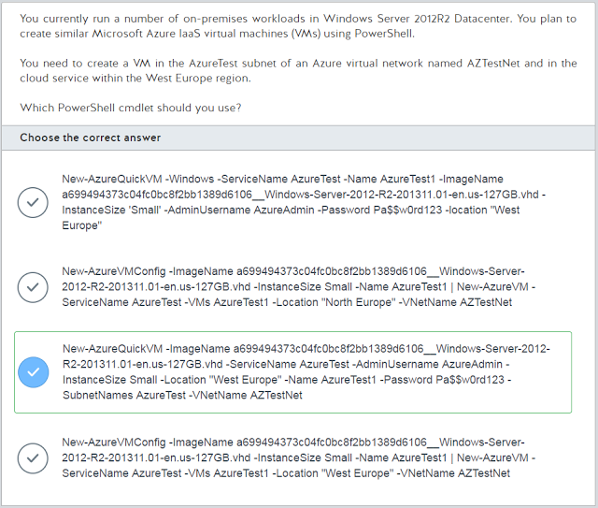](https://3.bp.blogspot.com/-K5UZPXfsmMg/WSCJLV3DV3I/AAAAAAAACho/pT6FxcUeQXc0lsjQkD0PlvUIcLuWOdesACLcB/s1600/2017-05-20%2Bat%2B23-20-09.png)

[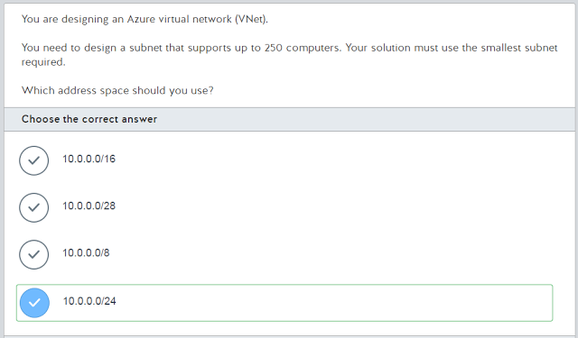](https://1.bp.blogspot.com/-isuJC6e5hbc/WSCJLLJarlI/AAAAAAAAChk/ChIWNnemMDIzmqQIY6WA5ZcLeHDCAL65ACLcB/s1600/2017-05-20%2Bat%2B23-20-26.png)

[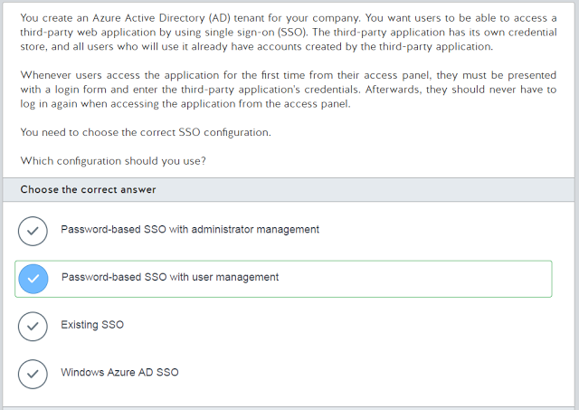](https://2.bp.blogspot.com/-8jTv7zxNsU8/WSCJMI3FBJI/AAAAAAAAChs/LPoIwEhBRzE9r_0EoZn4IqYIHovfiU9MACLcB/s1600/2017-05-20%2Bat%2B23-20-49.png)

[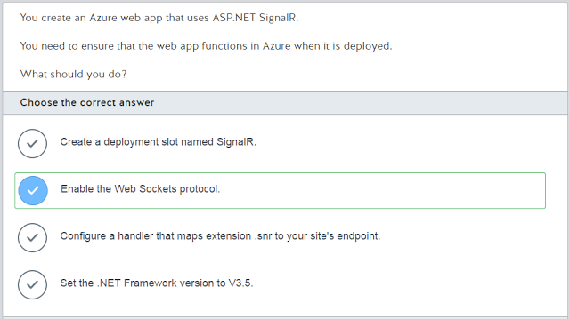](https://1.bp.blogspot.com/--vJul8CVR30/WSCJMHyHVTI/AAAAAAAAChw/Y0snxH5YP5ojWkfVSNNiYErJDMu8KY3TACLcB/s1600/2017-05-20%2Bat%2B23-21-15.png)

[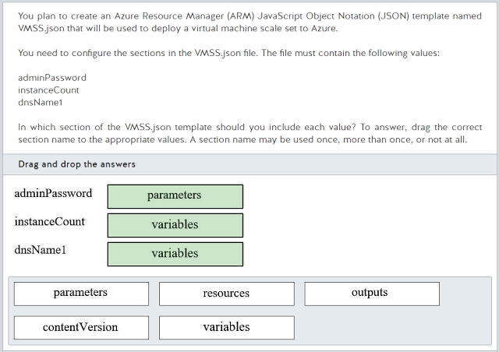](https://1.bp.blogspot.com/-SpiTon-kh0g/WSCJMbU3wlI/AAAAAAAACh0/yKFcQRw6RaAlXELPQn72rxoK6zRZPMUTQCLcB/s1600/2017-05-20%2Bat%2B23-21-42.png)

[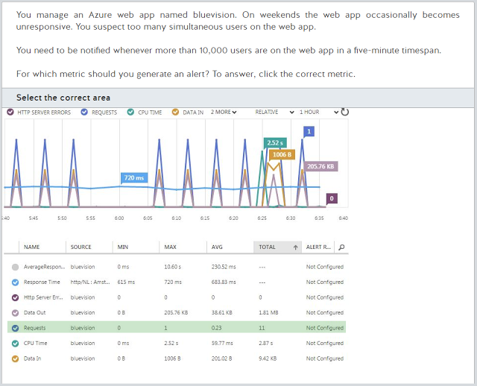](https://3.bp.blogspot.com/-f_yJxxjdgow/WSCJN6dgKII/AAAAAAAACiA/qfSHIrehg0E88qUdY8vy0j-gTk009S5RwCLcB/s1600/2017-05-20%2Bat%2B23-21-55.png)

[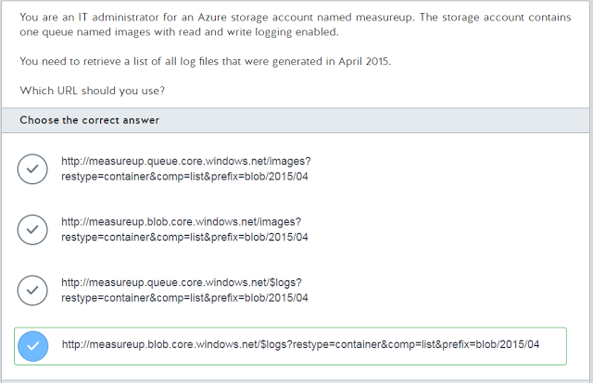](https://1.bp.blogspot.com/-F-JHvjY7Wvk/WSCJNbf9zMI/AAAAAAAACh4/T1g2JYXXFtUtZkRBlxMOwf5gwMTLnZRlQCLcB/s1600/2017-05-20%2Bat%2B23-22-11.png)

[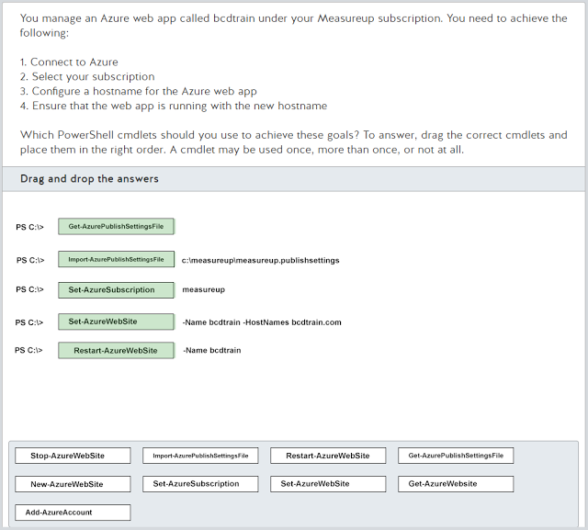](https://1.bp.blogspot.com/-WfQo0DWNU1Q/WSCJNsACufI/AAAAAAAACh8/RBydJfhk7uEHvwd315KEYpUd0gGZJJ8dgCLcB/s1600/2017-05-20%2Bat%2B23-22-50.png)

[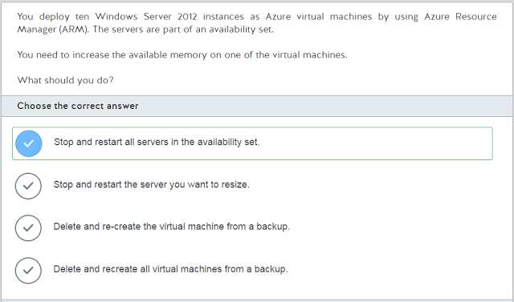](https://2.bp.blogspot.com/-rc3mXpFcKNc/WSCJOECeGLI/AAAAAAAACiE/pVm9WWn9Bzcng-2TNqYUTb62zWG56M3YACLcB/s1600/2017-05-20%2Bat%2B23-23-05.png)

[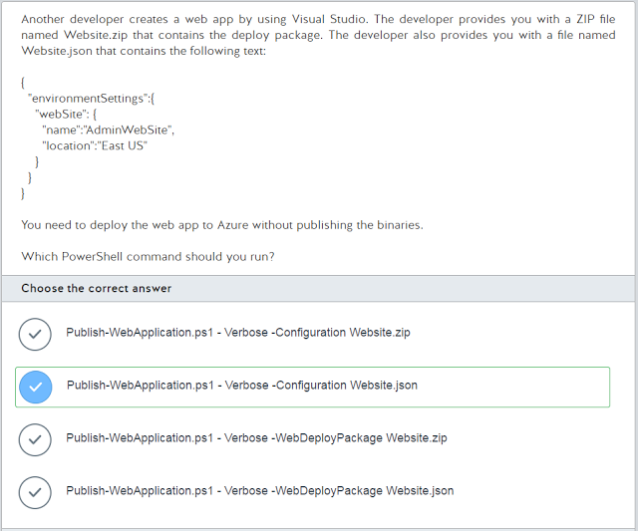](https://2.bp.blogspot.com/-E-jqpXELOjI/WSCJOwUYGEI/AAAAAAAACiI/WM5u0vlrASch_AoHLMCYN-Di24hShzItgCLcB/s1600/2017-05-20%2Bat%2B23-31-18.png)

[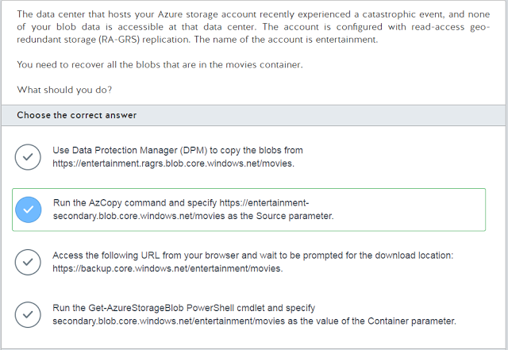](https://2.bp.blogspot.com/-ysTN0vbkzCg/WSCJPZ_vo8I/AAAAAAAACiM/H7eGOM-zdq8aMLX7_BtoGLe_Duxcu3DoQCLcB/s1600/2017-05-20%2Bat%2B23-31-36.png)

[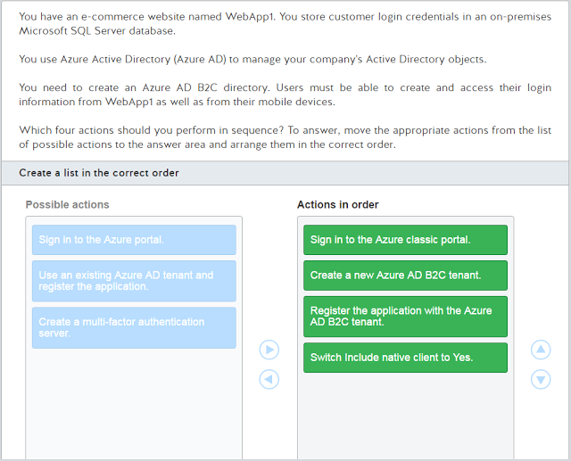](https://4.bp.blogspot.com/-bisMbuaUkrg/WSCJPiBXHtI/AAAAAAAACiQ/vU7ZPNiyvWosyzp8e0AXHgYRa9_77aO3QCLcB/s1600/2017-05-20%2Bat%2B23-31-56.png)

[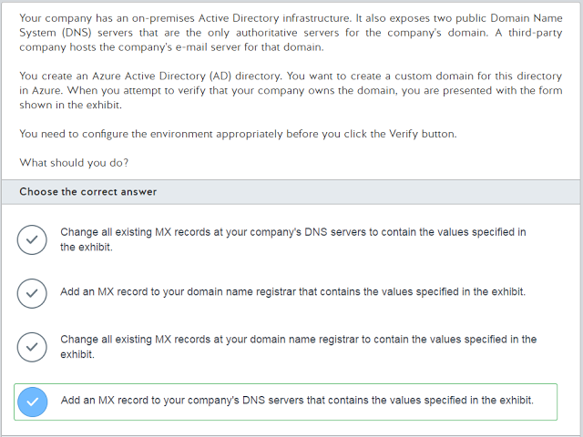](https://2.bp.blogspot.com/-8DVgGcqDybI/WSCJQLWOw1I/AAAAAAAACiU/bP3_-qLYchQsRqKInSbKm7MSkoCkDasrwCLcB/s1600/2017-05-20%2Bat%2B23-33-20.png)

[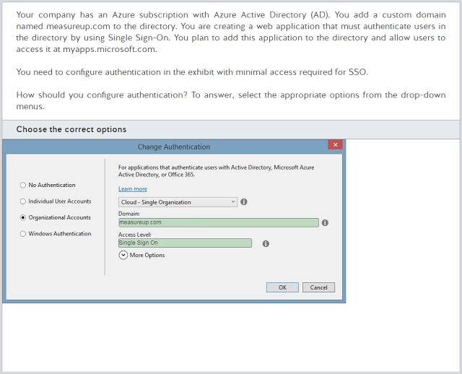](https://2.bp.blogspot.com/-Ihzsht362CU/WSCJREAisjI/AAAAAAAACic/rYJ8J04BK8swVELumJh9lJegDJkepxuoACLcB/s1600/2017-05-20%2Bat%2B23-33-34.png)

[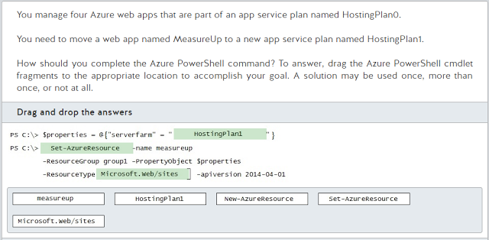](https://3.bp.blogspot.com/-SAGUUpD1QiA/WSCJRKuj2GI/AAAAAAAACiY/ZRoroHr_E5wz-jHdNgwj_-MXdmfWm3wkwCLcB/s1600/2017-05-20%2Bat%2B23-33-49.png)

[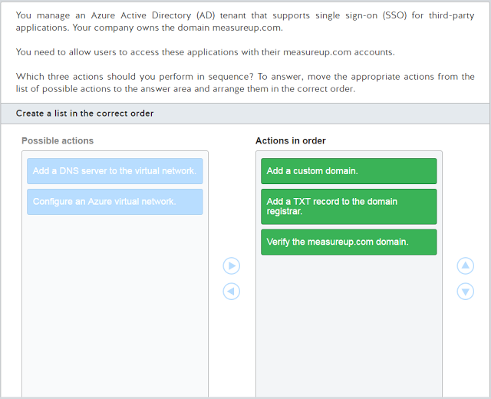](https://2.bp.blogspot.com/-1iQIqFSlaYk/WSCJRQgS9VI/AAAAAAAACig/IkfRapmH1eUGd0fQ9BGyBm8bYMvav-U5QCLcB/s1600/2017-05-20%2Bat%2B23-34-07.png)

[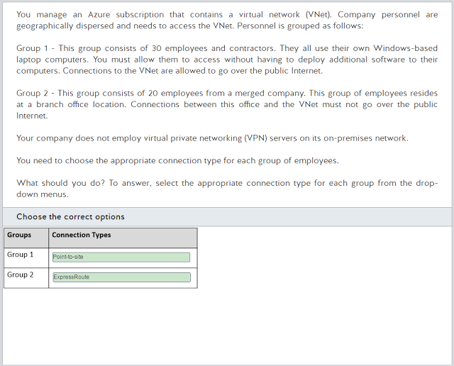](https://2.bp.blogspot.com/-3hsnAYmcvuk/WSCJSRJhSZI/AAAAAAAACik/tII76hqI9wcYdaTU_IgxdAiS5Lx-jqEngCLcB/s1600/2017-05-20%2Bat%2B23-34-19.png)

[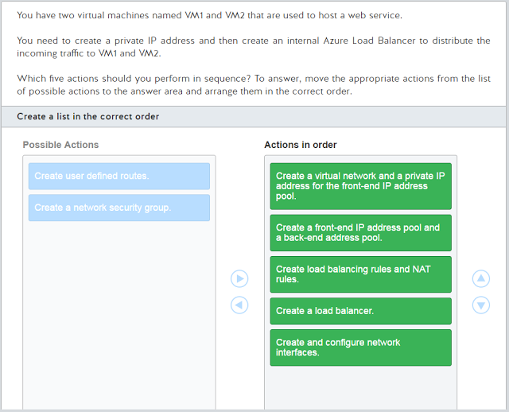](https://2.bp.blogspot.com/-mCS1YYsWzFA/WSCJSfNqIPI/AAAAAAAACio/h2VGE5OiQQsQxByczF3GGLmaAEfdZvRQwCLcB/s1600/2017-05-20%2Bat%2B23-34-35.png)

[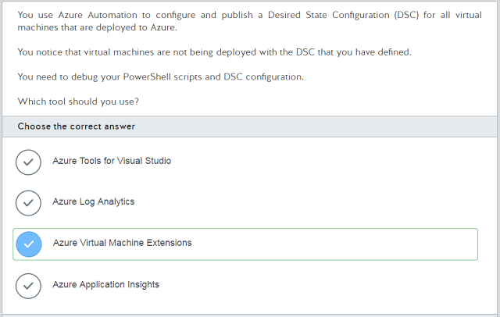](https://4.bp.blogspot.com/-UzmYy8nmOyM/WSCJSlRg-HI/AAAAAAAACis/UBJ_nQsoU1UgIzgamlOWJw6blSp2Wib7ACLcB/s1600/2017-05-20%2Bat%2B23-34-55.png)

[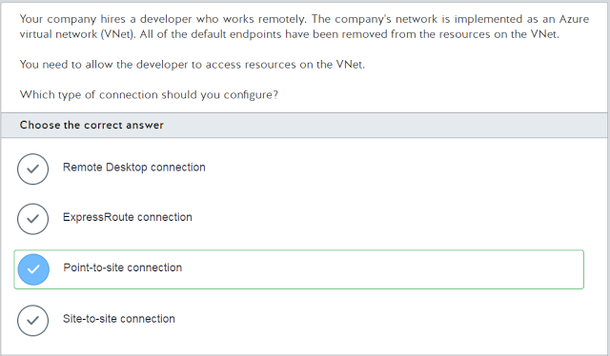](https://4.bp.blogspot.com/-TXg4vjKtg_c/WSCJTOJ8RUI/AAAAAAAACi0/OmWId_oDx50ZUYbK6ZtJjzwytUFBHPYNQCLcB/s1600/2017-05-20%2Bat%2B23-35-15.png)

[](https://3.bp.blogspot.com/-330P9s1sXi0/WSCJTfxzneI/AAAAAAAACiw/KR16nK1z4Mwv6okAf0ao8hqt4DpjpZ7qwCLcB/s1600/2017-05-20%2Bat%2B23-35-36.png)

[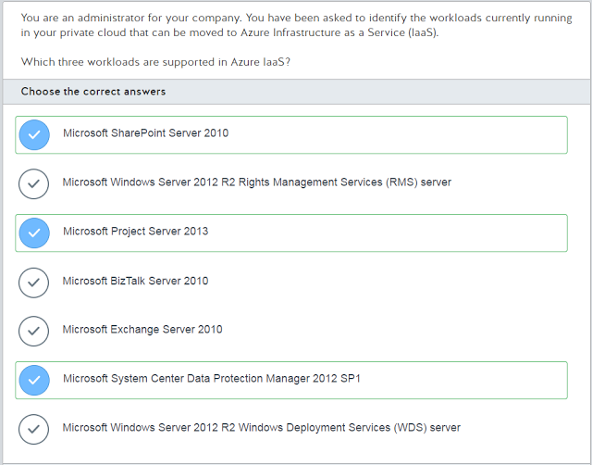](https://2.bp.blogspot.com/-DuJ-Brf88qE/WSCJT0Jgo-I/AAAAAAAACi4/-fAy0QnpRDo-x4WQks1482JiFxJhvQVAACLcB/s1600/2017-05-20%2Bat%2B23-35-53.png)

[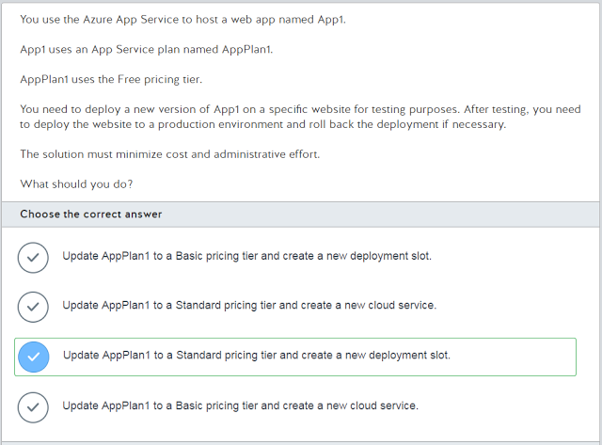](https://3.bp.blogspot.com/-rQVt9KHCJZI/WSCJUbiZBiI/AAAAAAAACi8/ToyQwoBlyzo-Fv4bTgeIpCAPWTYti4jAwCLcB/s1600/2017-05-20%2Bat%2B23-36-08.png)

[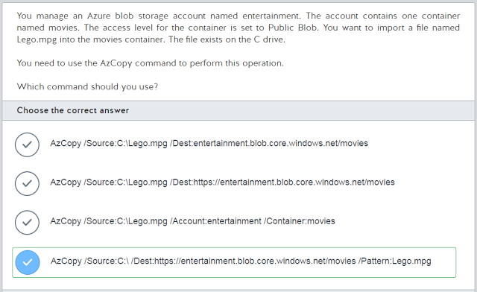](https://1.bp.blogspot.com/-kLXvq9-zxVI/WSCJUrbsMxI/AAAAAAAACjA/h2dZSubH-f81xn_iPRNBmniu7srnLYJ-ACLcB/s1600/2017-05-20%2Bat%2B23-36-22.png)

[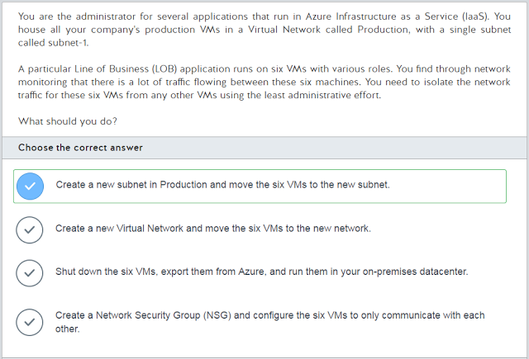](https://4.bp.blogspot.com/-VC0wGRdEQXU/WSCJU5wHA-I/AAAAAAAACjE/VRy02HwBCgwVE1VUKfcO12MgF_QpDZbwgCLcB/s1600/2017-05-20%2Bat%2B23-36-35.png)

[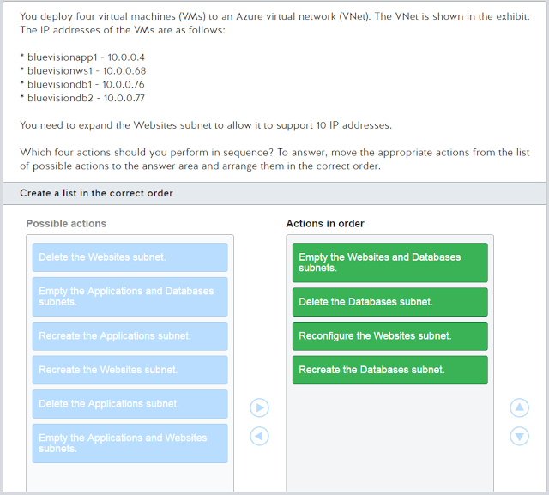](https://3.bp.blogspot.com/-HVOP3NXj8wo/WSCJVPFQeTI/AAAAAAAACjI/sYRuSimCBqMu1mWX99vWpBLu75hdE6L1gCLcB/s1600/2017-05-20%2Bat%2B23-36-53.png)

[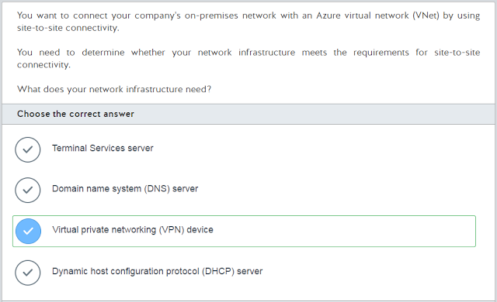](https://4.bp.blogspot.com/-GhVB7w1OfHc/WSCJWPekfbI/AAAAAAAACjM/yxqD2W0-7aEe3oHZzWAxnOdvjHBJXHanwCLcB/s1600/2017-05-20%2Bat%2B23-37-06.png)

[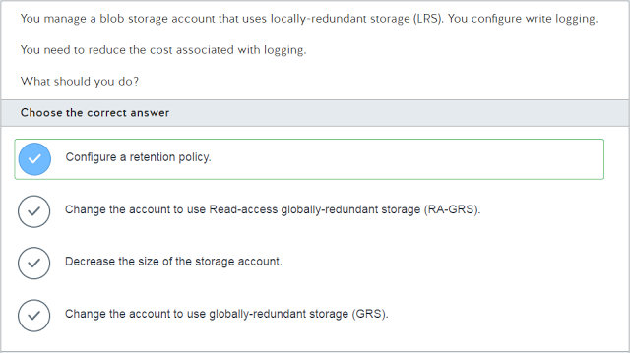](https://2.bp.blogspot.com/-o-LzFJDjinw/WSCJWIDwQFI/AAAAAAAACjQ/_DY--dHQc4IXF9u0cj1xnGpIeZE_fZxIQCLcB/s1600/2017-05-20%2Bat%2B23-37-19.png)

[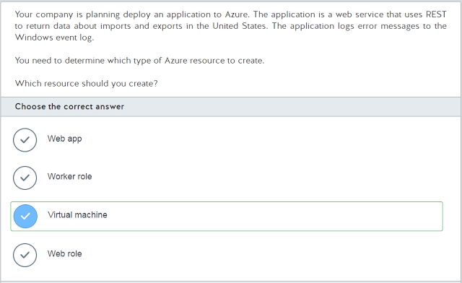](https://2.bp.blogspot.com/-oJLMpsadbF4/WSCJWXNwLEI/AAAAAAAACjU/EBS1A7YQX_UZVMNGiO1_zb3Sabv61l9dgCLcB/s1600/2017-05-20%2Bat%2B23-37-35.png)

[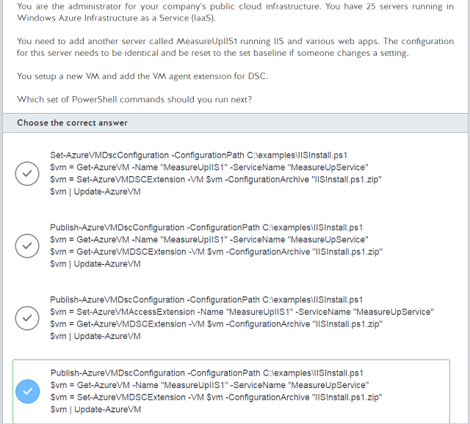](https://3.bp.blogspot.com/-mx2km1T0ImI/WSCJXo929lI/AAAAAAAACjc/tE0ummGAr04mZO75gInC157mTvQCmhEHgCLcB/s1600/2017-05-20%2Bat%2B23-38-00.png)

[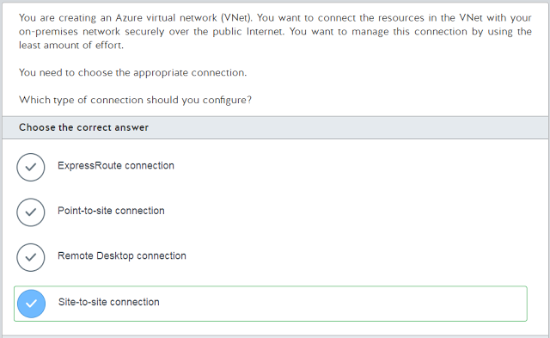](https://4.bp.blogspot.com/-o1eTlikiWmQ/WSCJW0W7pGI/AAAAAAAACjY/qW0fLuHZBA8zU0mcqm51ggqKB8cQTa0VgCLcB/s1600/2017-05-20%2Bat%2B23-38-14.png)

[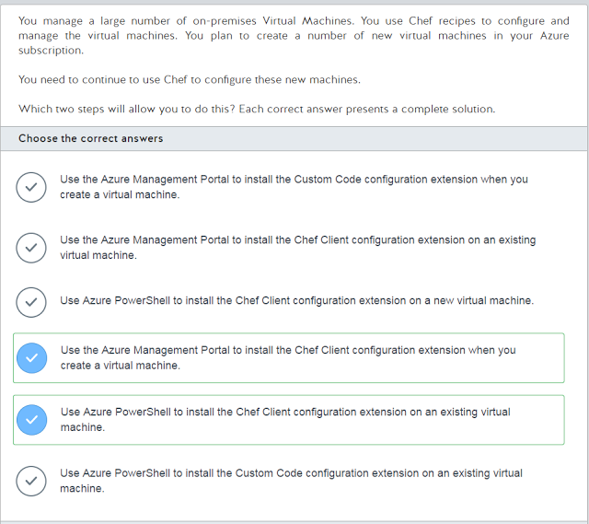](https://3.bp.blogspot.com/-IrTeEwktHM4/WSCJXjq8RlI/AAAAAAAACjg/bzJG3RvsZkIy51rDw4mH5t5rd1HLZ7hEQCLcB/s1600/2017-05-20%2Bat%2B23-38-41.png)

[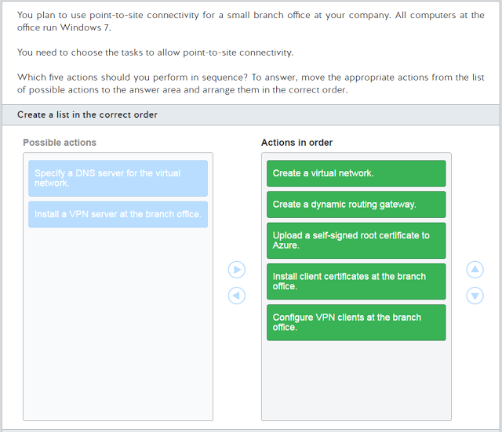](https://4.bp.blogspot.com/-1EDZCCd8_ic/WSCJYPw8JMI/AAAAAAAACjk/xA4j7fcuQ-ADL_x7AE2znqcM8dQ-3hp5ACLcB/s1600/2017-05-20%2Bat%2B23-39-03.png)

[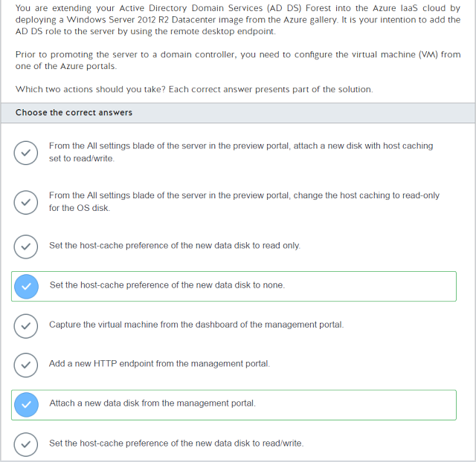](https://1.bp.blogspot.com/-rXxmR91MKDQ/WSCJYw-Sl3I/AAAAAAAACjo/FqDu3mONfuoW8XLkqTOBphXzRtkKGHEawCLcB/s1600/2017-05-20%2Bat%2B23-39-36.png)

[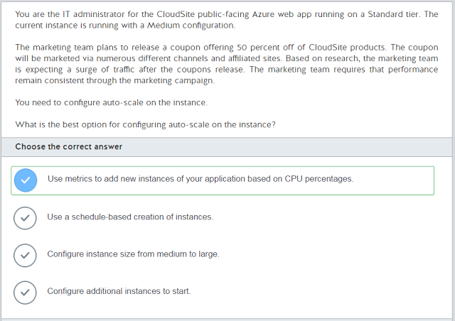](https://4.bp.blogspot.com/-4fDDMkDASO4/WSCJZCxu8YI/AAAAAAAACjs/OCIQBsG2dmktp7Q_xGo5hWaqkpHN93nbwCLcB/s1600/2017-05-20%2Bat%2B23-39-56.png)

[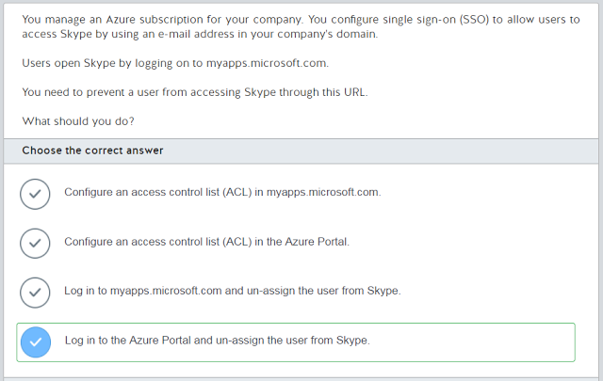](https://2.bp.blogspot.com/-EXpAKjq3JVI/WSCJZFY1vsI/AAAAAAAACjw/GjSA36dFoz0iNoPK_7kPxu0wR0u8ygdgQCLcB/s1600/2017-05-20%2Bat%2B23-40-16.png)

[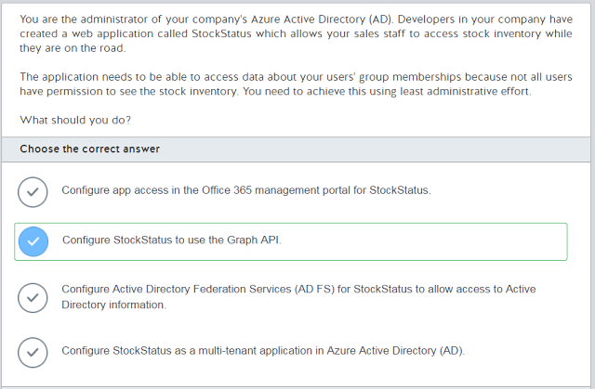](https://1.bp.blogspot.com/-svRXdZJaYOw/WSCJZx17efI/AAAAAAAACj0/4LDmJN4qHkw8OH-LJSLmq-qetmpfo3-ygCLcB/s1600/2017-05-20%2Bat%2B23-40-37.png)

[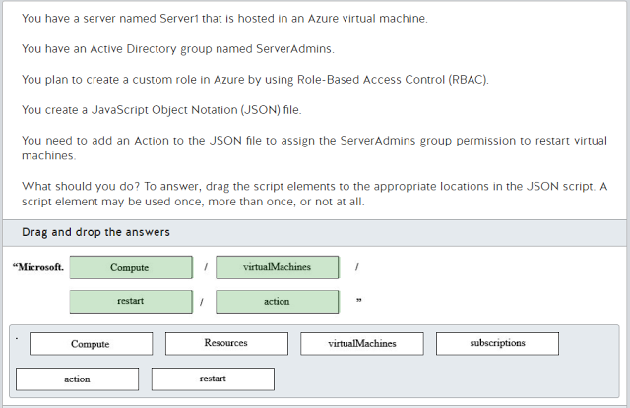](https://2.bp.blogspot.com/-b0oVfbDd8zs/WSCJaFsoQ7I/AAAAAAAACj4/1D9eCVK5lZIvOsL-fIzAzGG41-M-GYX4gCLcB/s1600/2017-05-20%2Bat%2B23-41-02.png)

[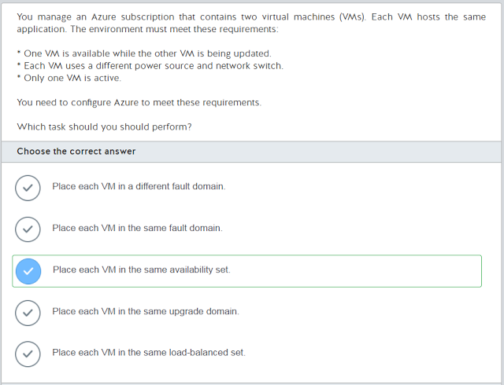](https://3.bp.blogspot.com/-Tn5hNxjkkO4/WSCJabsVViI/AAAAAAAACj8/K631A4eQ894kNYm4hYEIVoUQl55UAyUkwCLcB/s1600/2017-05-20%2Bat%2B23-41-24.png)

[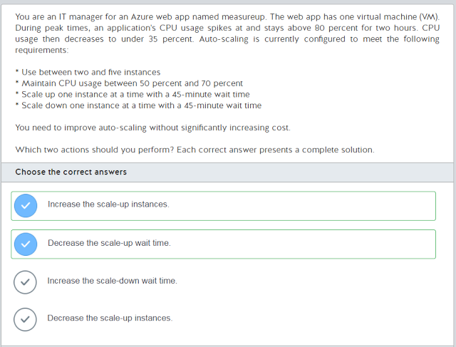](https://3.bp.blogspot.com/-oXocM7qbIk8/WSCJbbpUYZI/AAAAAAAACkA/TztMFH0cVoAe7LPMVnIrGoQAz0N4PrQPgCLcB/s1600/2017-05-20%2Bat%2B23-41-47.png)

[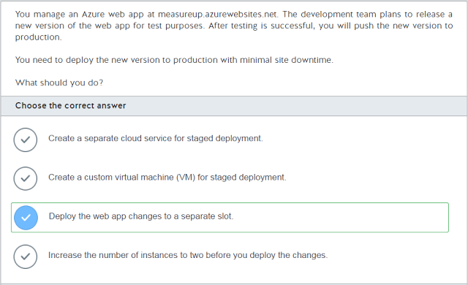](https://3.bp.blogspot.com/-5nw7vOIXxbM/WSCJbQuexyI/AAAAAAAACkE/zcOehFZfMIwBfKYryyZYDFC30UQ03qbfgCLcB/s1600/2017-05-20%2Bat%2B23-42-02.png)

[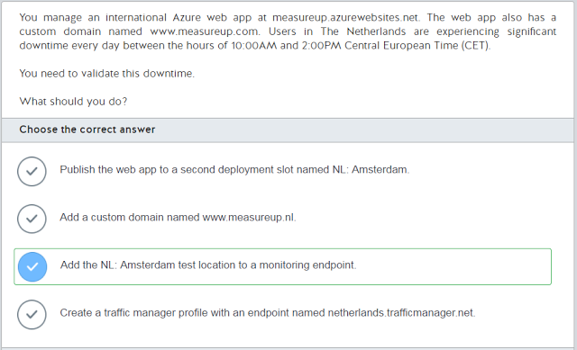](https://3.bp.blogspot.com/-JO6KOSxbox4/WSCJbuiW3vI/AAAAAAAACkI/6sLagTUTe28l1c_uwsTHf-RqEBKwmno4wCLcB/s1600/2017-05-20%2Bat%2B23-42-19.png)

[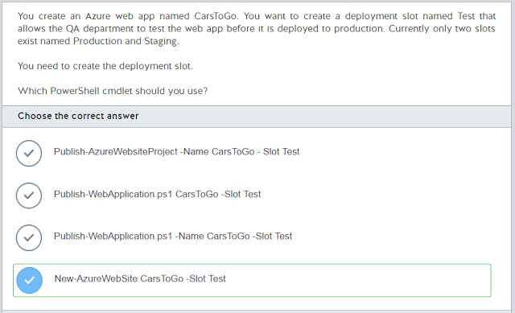](https://1.bp.blogspot.com/-f8umRKSvpho/WSCJcltaVsI/AAAAAAAACkQ/7iNxGI-mJ7s2_eJRCIcXYYJlfewdNzNSgCLcB/s1600/2017-05-20%2Bat%2B23-42-36.png)

[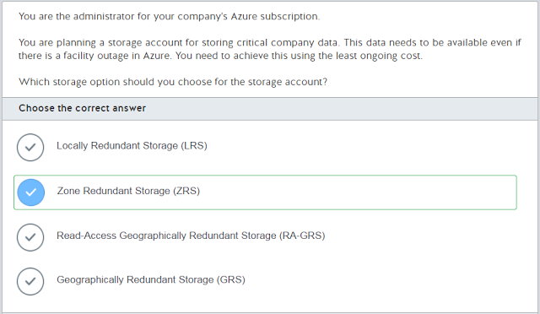](https://2.bp.blogspot.com/-jcBV1Cuc1IA/WSCJcQ4tfcI/AAAAAAAACkM/EckLKVlTXM0WzBx-exSXRDZHrXcvQNsrACLcB/s1600/2017-05-20%2Bat%2B23-42-50.png)

[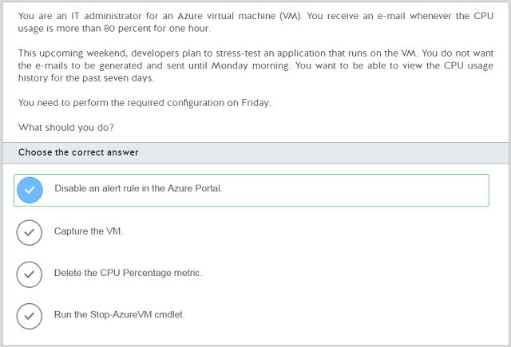](https://3.bp.blogspot.com/--0QwrQn05PM/WSCJciO3BXI/AAAAAAAACkU/Mj0EoMWse4AceK4OZfNZmyDVGJADq9jFgCLcB/s1600/2017-05-20%2Bat%2B23-43-04.png)

[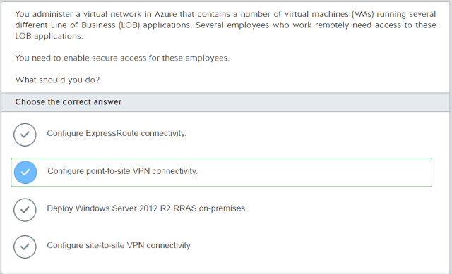](https://4.bp.blogspot.com/-SktaDIbLwFA/WSCJePAIVoI/AAAAAAAACkY/Oano2cR_tKUEmVh26R-2lms4T2R6T7L_wCLcB/s1600/2017-05-20%2Bat%2B23-43-18.png)

[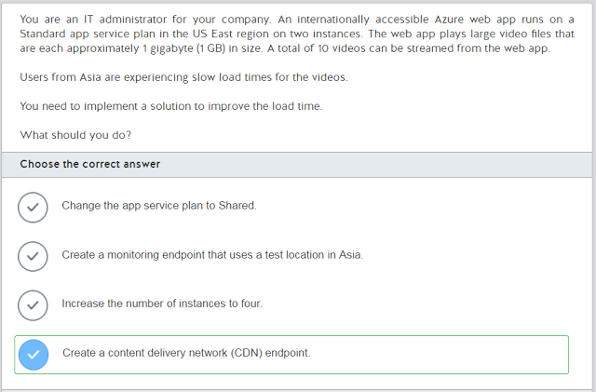](https://4.bp.blogspot.com/-tP5rqUSReUU/WSCJePKYidI/AAAAAAAACkc/1655EWtSBlsRAqbKO4l3Z5RLgRMXs1jzwCLcB/s1600/2017-05-20%2Bat%2B23-43-38.png)

[](https://2.bp.blogspot.com/-yMCW2gzxkvc/WSCJedh1LVI/AAAAAAAACkg/X3VTcokxAzwEVrirHU4G8ZFp8fzhL0g1QCLcB/s1600/2017-05-20%2Bat%2B23-43-55.png)